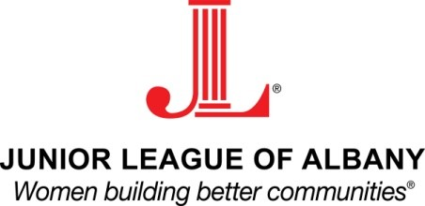
American Girl Committee Meeting Agenda
Meeting scheduled August 14, 2014
7:00 PM, Panera Bread, Latham Farms

- Additions or Changes to Agenda
- Overview of Roles
  - Chair/co-chair
  - Sponsors
  - Promotions (including posters, printing, program)
  - Vendors
  - Models
  - Raffles
  - Volunteer Management
- Review of to-do List from Last Year’s Committee
  - Assign tasks for August, September
- Sponsorships
  - Sponsorship menus from Dolly’s, previous American Girl
  - Additions/changes to same
  - Identify potential sponsor master list
- Promotions
- Vendors
  - Review last year’s vendor contract
  - Identify potential vendors, plan for contacting same
  - Discuss overlap with raffles
- Models
  - Review last year’s model application
  - Discuss next steps
- Raffles
  - Review information from last year, identify what worked and didn’t
- Volunteer Management
  - Start accepting shift assignments from members ASAP
- Project: Proposed girl hair salon
  - Think through scheduling possibilities
  - Talk to Kim about possibility of doing this
  - Contact local salons, hair schools
- Set next meeting dates

