Junior League of Albany, Inc.
Table of Contents

JLA Information
Focus/Mission/Vision
Certificate of Incorporation
History Year by Year
Past Presidents
Sustainer Bowl Winners
Yates Award Winners
JLA Recognition Award

AJLI Information
2012 Member 411

General Information
2012-2013 Board Contact Information
2012-2013 Who to Call…
2012-2013 Membership Requirements
2012-2013 Placement
Job Descriptions

Bylaws

Standing Rules

2011-2014 Strategic Plan

Membership Directory

Placement Specific information

JLA Mission, Focus and Vision Statements

Mission
The Junior League of Albany is an organization of women committed to promoting voluntarism, developing the potential of women and improving communities through the effective action and leadership of trained volunteers. Its purpose is exclusively educational and charitable.

Focus
The Junior League of Albany has adopted as its focus area Women’s and Children’s Health issues.

Vision
The Junior League of Albany is recognized as a dynamic organization committed to empowering all women of the Capital District to maximize their leadership potential, thus enabling them to respond to and meet community needs by inviting positive solutions.

“Women Building Better Communities”

CERTIFICATE OF INCORPORATION

THE JUNIOR LEAGUE OF ALBANY, INC.
(As amended through August 15, 1996)

We, the undersigned, for the purpose of forming a membership corporation, pursuant to the Membership Corporation Law of the State of New York, hereby certify:

- The name of the corporation shall be the Junior League of Albany, New York, Inc.

- The Junior League of Albany, New York, Inc. is an organization of women committed to promoting voluntarism, developing the potential of women and improving communities through effective action and leadership of trained volunteers. Its purpose is exclusively educational and charitable.

- The territory in which its operations are principally to be conducted is the County of Albany, State of New York.

- The city and county in which its office is to be located are the City of Albany and County of Albany, New York.

- The number of its directors shall not be less than (10) nor more than twenty (20).

- The names and residences of the directors until the first annual meeting are:

NAMES RESIDENCES
Elizabeth C. Tracy Altamont, New York
Mary K. Newman Albany, New York
Alice J. Taylor Albany, New York
Louise B. Gibson Glenmont, New York
Carol K. Headley Loudonville, New York
Constance T. Brown Albany, New York
Eleanor S. Boyd Loudonville, New York
Dorothy D. Farrell Loudonville, New York
Margaret K. Bell Albany, New York
Doris S. Stevens Albany, New York
Dorothy Ellis Albany, New York
Agnes Dugan Albany, New York
Louise B. Bryan Loudonville, New York

- All of the subscribers to this certificate are of full age; at least two-thirds of them are citizens of the United States; at least one of them is a resident of the State of New York. Of the persons named as directors, at least one is a citizen of the United States and a resident of the State of New York.

IN WITNESS WHEREOF, we have made, subscribed and acknowledged this certificate this 5th day of March 1934.

The History Of The Junior League Of Albany, Inc.

  - FUNDRAISERS – Sale of fancy articles.
IN-LEAGUE – 19th city to establish a Junior League under the leadership of Laura Spencer Townsend and Grace S. Carter.
COMMUNITY SERVICE PROJECTS – Knitted goods for soldiers overseas.

  - IN-LEAGUE – $1,000 Liberty Bond given by Grace S. Erdman. Start of the Community Fund.
COMMUNITY SERVICE PROJECTS – Volunteers for Child’s Hospital Home for Incurables and Trinity Diet Kitchen.

  - FUNDRAISERS – “The Nine O’clock Revue” Play.
IN-LEAGUE – Formation of the point systems, Provisionals and Legislative Committees. Sustainers exempted from League obligations.
COMMUNITY SERVICE PROJECTS – Furnished a laboratory at the Home for Incurables.

  - FUNDRAISERS – The “Nine O’clock Revue” Play.
IN-LEAGUE – Formation of a Finance Committee.
COMMUNITY SERVICE PROJECTS – $1,000 given to Disabled War Veterans. Established South End Dispensary, a clinic for preschool children.

  - FUNDRAISERS – “Prince Bonnie” Play.
IN-LEAGUE – Formation of Church and Hospitality Committees.
COMMUNITY SERVICE PROJECTS – Dental and Mental Hygiene Clinics added to West End Clinics.

  - FUNDRAISERS – Follies, “Noah’s Ark,” Two Assemblies.
IN-LEAGUE – Establishment of a Recording Secretary and Corresponding Secretary. bi-monthly meetings rather than weekly meetings.
COMMUNITY SERVICE PROJECTS – Addition of Ear, Nose and Throat Clinics to West End Clinics.

1925-1926 FUNDRAISERS – Rummage Sale, Two Assemblies,Cabaret.
COMMUNITY SERVICE PROJECTS – Addition of Eye Clinic to West End Clinic. Helped sponsor Albany’s first Community Chest.

1926-1927 FUNDRAISERS – Rummage Sale, Two Assemblies, “Cruise.”
IN-LEAGUE – First regional conference held in Albany. Formed Dramatic Committee.

1927-1928 FUNDRAISERS – Rummage Sale, Character Sketches of Miss Cornelia Otis Skinner, Two Assemblies.

IN-LEAGUE – Established monthly NewsSheet and monthly business meetings. Defined a professional member. Proposed the Troy Junior Service League for membership to the Association of Junior Leagues.

COMMUNITY SERVICE PROJECTS – West End Clinic turned over to the Albany Guild for Public Health Nursing (later the Visiting Nurses Association).

1928-1929 FUNDRAISERS – Water Pageant, Rummage Sale, Junior League Day at Ten Eyck’s.

IN-LEAGUE – Established a League office and headquarters – “Club Room.”

COMMUNITY SERVICE PROJECTS – Established the pushcart patient library at Albany Medical Hospital.

1929-1930 FUNDRAISERS – Rummage Sale, Junior League Day at Whitney’s and Ten Eyck’s.

IN-LEAGUE – Formed Puppet Committee and Future Policy Committee.

COMMUNITY SERVICE PROJECTS – Assisted in the establishment of an Occupational Therapy Department at Albany Medical Hospital (eight-year project).

1930-1931 FUNDRAISERS – Rummage Sale, Old Movie Tickets, Operated Times-Union for one day.
IN-LEAGUE – Formed an Administrative Account, Charity Account and Unemployment Fund.

  - FUNDRAISERS – Rummage Sale, Operated Times-Union for one day, Christmas Dance.
IN-LEAGUE – Formed a Glee Club.

1932-1933 FUNDRAISERS – Salvage Sale, Horse Show, Junior League Day at David’s.
IN-LEAGUE – Formed the Placement Committee and the Garden Club.
COMMUNITY SERVICE PROJECTS – Set up two reading rooms in local libraries for unemployed. Gave $1,000 to Community Chest for relief of unemployed.

1933-1934 FUNDRAISERS – Musical Revue “Albany Ahoy.”
IN-LEAGUE – Albany League incorporated. Held a Tri-City Conference of Leagues.
COMMUNITY SERVICE PROJECTS – $1,000 given to Community Chest for relief of unemployed.

  - FUNDRAISERS – No Fundraiser.
COMMUNITY SERVICE PROJECTS – Assisted in set-up of patient workshop at Mosher Memorial Hospital.

1935-1936 FUNDRAISERS – No Fundraiser.
IN-LEAGUE – Dispensed “Club Room.”

  - FUNDRAISERS – Christmas Dance, Revue “Hi-De-Ho.”
COMMUNITY SERVICE PROJECTS – Ventured into radio to promote Community Service Drive.

1937-1938 FUNDRAISERS – Christmas Dance.
IN-LEAGUE – Association of Junior Leagues published for the first time handbooks on bylaws, policies, committees, etc.

1938-1939 FUNDRAISERS – Tinsel Ball.
COMMUNITY SERVICE PROJECTS – Albany Hospital assumes full responsibility for Occupational Therapy Department.

1939-1940 FUNDRAISERS – No Fundraiser.
COMMUNITY SERVICE PROJECTS – Dramatic Committee entertained approximately 5,000 children with 10 performances. Formed Volunteer Placement Bureau.

1940-1941 FUNDRAISERS – Tinsel Ball, two Dinner Dances.
IN-LEAGUE – Formed a Future Activities Committee to study projects.
COMMUNITY SERVICE PROJECTS – Established the Albany Children’s Theater, an outgrowth of the Dramatic Committee.

  - FUNDRAISERS – No Fundraisers.
COMMUNITY SERVICE PROJECTS – Volunteer Placement Bureau joined the Defense Council. Established a Child Care Center for working mothers.

1942-1943 FUNDRAISERS – Tinsel Ball (evening highlight was a wrestling match).
IN-LEAGUE – Began evening meetings. Formed the Educational Committee.
COMMUNITY SERVICE PROJECTS – National recognition as first Junior League to set up Child Care Center to meet the war needs.

  - FUNDRAISERS – Tinsel Ball, Rummage Sale.
COMMUNITY SERVICE PROJECTS – Moved the Child Care Center to Albany Medical Hospital to care for children of hospital personnel.

1944-1945 FUNDRAISERS – Silver Tea.
IN-LEAGUE – Comprehensive Educational Program – “Rehabilitation of Men and Women in the Post-War Period.”
COMMUNITY SERVICE PROJECTS – Sponsored the children’s radio program, “Books Bring Adventure.”

1945-1946 FUNDRAISERS – Tinsel Ball.
IN-LEAGUE – Revised the constitution.
COMMUNITY SERVICE PROJECT – Second children’s radio series, “Books Bring Adventure.” Assisted in organizing and operating the Albany Blood Bank (Red Cross took over in 1949).

  - FUNDRAISERS – Tinsel Ball, Silver Tea.
IN-LEAGUE – Revised the Legislative Committee.
COMMUNITY SERVICE PROJECT – Assisted in the founding of Albany Youth Council.

  - FUNDRAISERS – Follies, Tinsel Ball.
IN-LEAGUE – Formed a Finance Committee.
COMMUNITY SERVICE PROJECT – Co-sponsored, with the Junior Leagues of Troy and Schenectady, three children’s radio programs.

  - FUNDRAISERS – Tinsel Ball, Silver Tea.
IN-LEAGUE – Placement began the system of personal interviews.
COMMUNITY SERVICE PROJECT – Expanded the children’s radio programs to in-school listening. Began assistance to Ten Broeck Mansion.

1949-1950 FUNDRAISERS – Rummage Sale, Square Dance, Tinsel Ball, Silver Tea, Picnic.
IN-LEAGUE – Published a brochure on League accomplishments for citywide distribution.
COMMUNITY SERVICE PROJECT – Instituted remedial reading for institutional children at Albany Home for Children. Restored a “Junior League Room” at Ten Broeck Mansion. Financed equipment for a Well-Child Demonstration Clinic.

  - FUNDRAISER – Auction Sales, Follies.
COMMUNITY SERVICE PROJECTS – Produced a new radio program for primary grades, “Pictures From the Air.”

  - FUNDRAISERS – Square Dance, Picnic, Rummage Sale, Tinsel Ball.
IN-LEAGUE – Formation of an active sustaining group with Board and Committee representatives.
COMMUNITY SERVICE PROJECTS – Wrote and co-sponsored with New York State Education Department and 19 Junior Leagues statewide the radio program “Price of Liberty,” which ran for six years. Received State and national acclaim for the production. Co-sponsored with the Council of Jewish Women the opening of the Senior Citizens Center.

  - FUNDRAISERS – Tulip Ball, Tinsel Ball, Cookbook.
IN-LEAGUE – Established the Sustainers’ Bowl.

  - FUNDRAISERS – Fall Picnic, Tinsel Ball, Three-Day “Next-to-New Sale.”
IN-LEAGUE – Formed Community Arts Committee, Puppeteers and Choraleaguers.
COMMUNITY SERVICE PROJECTS – Produced movie, “These Are Your Neighbors” in conjunction with Community Chest Drive. Co-sponsored, with the Rotary Club, the Northeastern Speech Center (involved for 10 years).

  - FUNDRAISERS – Picnic, Next-to-New Sale, Tinsel Ball.
IN-LEAGUE – Started system of nametags at all Business Meetings. Provisionals now meet first in spring, rather than fall.
COMMUNITY SERVICE PROJECTS – Financial assistance to Hard-of-Hearing Clinic.

  - FUNDRAISERS – Follies ($10,000).
IN-LEAGUE – Raised dues to $11.00.

  - FUNDRAISERS – Next-to-New Sale, Tinsel Ball, Square Dance.
IN-LEAGUE – Adopted a “Guide to Procedure” for all Committee Chairs. Started Board Orientation.

  - FUNDRAISERS – Tinsel Ball, Movie “Heidi.”
IN-LEAGUE – Opened the “Next-to-New Shop” on October 15.

  - FUNDRAISERS – Shop, Tinsel Ball, Antiques Show.
COMMUNITY SERVICE PROJECTS – Co-sponsored with Albany Institute of History and Art a TV series explaining various phases of the Institute’s programs.

  - FUNDRAISERS – Shop, Tinsel Ball.
IN-LEAGUE – Start of the Scoop Sheet.

  - FUNDRAISERS – Follies ($11,000), Shop.
COMMUNITY SERVICE PROJECTS – Created an authentic Dutch Room at the Albany Institute of History and Art.

  - FUNDRAISERS – Shop, Tinsel Ball, Bake Sale.
IN-LEAGUE – Employed a full-time manager for the Shop.
COMMUNITY SERVICE PROJECTS – Financially assisted in the forming of the Albany Girls’ Club.

  - FUNDRAISERS – Shop, Tinsel Ball, Square Dance.
IN-LEAGUE – Dissolved the Ways and Means Committee.
COMMUNITY SERVICE PROJECTS – Assisted in forming a Citizens Planning Committee.

  - FUNDRAISERS – Shop, Tinsel Ball.
IN-LEAGUE – Began a rotating placement system for Provisionals.
COMMUNITY SERVICE PROJECTS – Helped finance the International Center. Formed a Young Audiences Program.

  - FUNDRAISERS – Shop, Tinsel Ball.
IN-LEAGUE – Formed the Publicity Committee.
COMMUNITY SERVICE PROJECTS – Established a weekly Community Arts Calendar in local newspaper.

  - FUNDRAISERS – Shop, Tinsel Ball.
IN-LEAGUE – Began the long-range sign-up for Shop work. Legislative Committee began working jointly with Women’s Legislative Forum.
COMMUNITY SERVICE PROJECTS – Terminated affiliation with Speech Center. Made a three-year commitment to Helderberg Workshop.

  - FUNDRAISERS – Shop.
IN-LEAGUE – Established Board Reference Manuals.

  - FUNDRAISERS – Follies ($14,500), Shop.
IN-LEAGUE – Celebrated 50th Anniversary.
COMMUNITY SERVICE PROJECTS – Helped establish the Albany Volunteer Bureau (three-year project).

  - FUNDRAISERS – Shop, Tinsel Ball.
IN-LEAGUE – Formed the Community Research and Project Development Committee. Formed the Paletteers.

  - FUNDRAISERS – Shop, Art Sale by Paletteers.
COMMUNITY SERVICE PROJECTS – Sponsored, with 13 other community organizations, the drug program “Junk.”

  - FUNDRAISERS – Shop.
IN-LEAGUE – Holiday Boutique at the Shop.
COMMUNITY SERVICE PROJECTS – Sponsored, with three other community organizations, “Albany As It Is – 1970.” Art Scholarship. Renovation of the Junior League Room at the Ten Broeck Mansion.

  - FUNDRAISERS – Shop.
IN-LEAGUE – Established the Patricia M. Yates Memorial Award.
COMMUNITY SERVICE PROJECTS – Volunteer Bureau became one of 30 Volunteer Action Centers in the U.S.

  - FUNDRAISERS – Shop.
IN-LEAGUE – AJLI begins “Area Concept” – Albany League joins Area II. Changed the length of all officers, except Treasurer, to one-year terms. Formed Advisory Planning Committee. State Public Affairs Seminar in Albany.
COMMUNITY SERVICE PROJECTS – Sponsored TV videotape “Bobby” on drug abuse. Supported area survey by Council of Community Services.

  - FUNDRAISERS – Shop.
IN-LEAGUE – New League brochure to community. Restructured the format of League Board, bylaws, job descriptions, etc.
COMMUNITY SERVICE PROJECTS – With Rotary Club, sponsored a three-year Bicentennial project at Ten Broeck Mansion. Sponsored Affirmative Action (three-year project).

  - FUNDRAISER – Shop.
IN-LEAGUE – Defined “professional member.”
COMMUNITY SERVICE PROJECTS – Sponsored “Moccasins and Wooden Shoes” (Bicentennial project) and Next Step, Inc. (three-year project).

  - FUNDRAISERS – Shop, Sale of Bicentennial notepaper.
IN-LEAGUE – AMP Process. “Moccasins and Wooden Shoes” show completed.
COMMUNITY SERVICE PROJECTS – Helped finance Next Step, Inc., a halfway house for women with alcoholism (three-year project). Affirmative Action received Junior League funds.

  - FUNDRAISERS – Shop, Tennis Exhibition.
IN-LEAGUE – Career Development.
COMMUNITY SERVICE PROJECTS – Architectural Accessibility Handbook, a joint project with the Junior Leagues of Troy and Schenectady. Sponsored opening event of Youth Festival Week. Helped finance Project Hope, a diversion program for adolescent girls. Also funded Widowed Person’s Services.

  - FUNDRAISERS – Shop.
IN-LEAGUE – New public relations brochure. Susan Green (President of AJLI) visited. Implementation of Advisory Status. Celebrated 60th Anniversary.
COMMUNITY SERVICE PROJECTS – Funded Project Hope. Permanency Planning Program (with Junior League of Troy and Welfare Research, Inc.). Printed brochure for Bus and Walking tour with Historic Albany and Albany Institute of History and Art. Co-sponsored Youth Festival Week. Made second payment to Next Step, Inc. Helped establish Kidspace at the Harmanus Bleecker Center.

  - FUNDRAISERS – Shop. Administrative Fundraisers: Auction at Ten Broeck Mansion, Boat Ride, Cohoes Music Hall and others.
IN-LEAGUE – Obtained five-year license from City of Albany to occupy 419 Madison Avenue as Headquarters. Relocated Shop and renovated building. Established Community Advisory Board.
COMMUNITY SERVICE PROJECTS – Produced a slide presentation “Runaways” for Project Equinox Runaway Youth Shelter. Made third payment to Next Step, Inc. and underwrote public relations brochure. Produced St. Anne’s volunteer training guide and edited monthly in-house and quarterly community publications. Continued educational training for tour guides for Historic Albany tours. Took Volunteer Career Development to community.

  - FUNDRAISERS – Shop. Administrative Fundraisers: Accents, Evening at ESYT, Brunch at Albany Country Club.
IN-LEAGUE – Opened Accents at Headquarters. Alice Weber (President of AJLI) visited.
COMMUNITY SERVICE PROJECTS – Formation of St. Peter’s Hospice interest group to develop program. Appointed Task Force to provide administrative assistance to Kidney Foundation of Northeastern New York. Provided financial support to the Child Abuse and Neglect Council. Provided funds for Kidspace.

  - FUNDRAISERS – Shop. Administrative Fundraisers: Accents, Evening at ESYT, Brunch at Albany Country Club.
IN-LEAGUE – Continued furnishing of Headquarters, Marking Room, Kitchen and Lounge. Co-sponsored, with the Spouse’s Association of the American College of OB/GYN, the Women’s Health Seminar. Offered in-depth courses in AMP and VCD in-League and to the community. Community Affairs was reconstructed and renamed Public Affairs.
COMMUNITY SERVICE PROJECTS – Served as volunteer coordinators and provided manpower in other areas of need for the development of Albany’s Ronald McDonald House. Provided many furnishings, audio/visual equipment, library books, a children’s corner and day care center. Fully funded St. Peter’s Hospice brochure. Provided partial funding for Kidspace International Craft week. Provided financial support to the Child Abuse and Neglect Aid Training program, Historic Albany’s Board meetings and the Arachne Weavers Guild Exhibit.

  - FUNDRAISERS – Shop, Accents.
IN-LEAGUE – Opened Accents year-round as Administrative Fundraiser. Voted in Cookbook project as a new fundraiser. Headquarters Meeting Room was furnished and use of Headquarters increased 25%. First draft of Annual Plan made and Sheila Holderness spoke on “New Approaches to Community Program.”
COMMUNITY SERVICE PROJECTS – Voted in Ronald McDonald House and Community Service Sentencing as projects. Formed two new interest groups: Milk for Life and Arts Project. AMP in-depth was offered to Junior Leagues of Troy and Schenectady. Increased use of Headquarters to community agencies.

  - FUNDRAISERS – Shop, Accents.
IN-LEAGUE – Combined Administrative and Community Trust Funds. Reduced Shop shifts and approved dues increase. Completed Five-Year Annual Plan and updated Professional Members List. Offered five separate training sessions at General Membership Meetings as well as a Placement Fair. Gave AMP in-depth and VCD courses as well as CPR and Stress Management.
COMMUNITY SERVICE PROJECTS – Completed Ronald McDonald House and Hospice project/film presentation. Voted in two new projects: Milk for Life and Arts Project. Gave $500 stipend to the winner of the Patricia McGuinness Yates Award. Participated with Junior League of Schenectady on workshop for the family. AMP course taught in the community.

  - FUNDRAISERS – Shop.
IN-LEAGUE – Accents closed as Administrative Fundraiser. Public Affairs Committee submitted written testimony on child sexual abuse. Shop shifts reduced. License renewed with City of Albany for use of 419 Madison Avenue. Joint meeting held with Troy and Schenectady Junior League Boards. Training Committee offered three training sessions at October General Membership Meeting. OSA and Skillsbank introduced by Placement Committee.
COMMUNITY SERVICES PROJECTS – “Going Places,” a guidebook to the Capital District, is published. AMP course taught in the community. Milk for Life and Community Service Sentencing projects completed. Dutch Room project and Emergency Food interest groups started. Cookbook recipe testing completed and title selected: The Stenciled Strawberry.”

  - FUNDRAISERS – Shop, Cookbook, stationery sales.
IN-LEAGUE – Membership endorsed stationery sales as Administrative Fundraiser. License renewed with City of Albany for use of 419 Madison Avenue. Shop celebrated its 25th anniversary. Cookbook Office set up. Training Committee offered eight training sessions at October General Membership Meeting. Cluster meeting held in Rochester with Leagues from Areas I and II.
COMMUNITY SERVICE PROJECTS – Four new interest groups formed: Empire State Rowing Regatta, Regional Food Bank, Early Breast Cancer Detection Group, Child Cancer Care. First printing of The Stenciled Strawberry Cookbook was completed and a marketing plan devised and implemented. AMP taught in the community.

  - FUNDRAISERS – Shop, Cookbook, stationery sales, Art Auction.
IN-LEAGUE – Membership endorsed an Art Auction as Administrative Fundraiser. Sustainer representative given voting position on Board. Ad Hoc Committee for Headquarters Acquisition recommended purchase of 419 Madison Avenue. Membership proposed purchase agreement. Carole Harte, AJLI President, visited Albany, Schenectady and Troy Leagues for a day of meetings. Area-wide seminar replaced by Training and Leadership Development Cluster Meetings.
COMMUNITY SERVICE PROJECTS – “Moccasins and Wooden Shoes” revised and reprinted. Tricentennial Trunk presentations made to Albany County fourth- grade classes. Membership voted to organize and coordinate a two-day Fall Family Festival as part of Albany’s Tricentennial Celebration. Albany Area Housing Opportunities and Samaritans of the Capital District received project funding. Second printing of The Stenciled Strawberry.

  - FUNDRAISERS – Shop, Cookbook, Stationery sales, Silent Auction, Art Auction.
IN-LEAGUE – A new mission statement was passed by AJLI. Rejoined New York State Public Affairs Committee (NYSPAC). Purchased Headquarters at 419 Madison Avenue. Added Project Review as a committee. Reorganized community board. Mary Briggs and Liz Foster from Area II Council visited to do marketing seminar.
COMMUNITY SERVICE PROJECTS – Donated “Moccasins and Wooden Shoes” books to several historical sites to be distributed to school-age children. Participated in the Tricentennial Parade – float was a replica of Headquarters. Coordinated the City Fair in Washington Park and the Rowing Regatta. Funded printing of a directory to be published by Albany Teen Consortium. Agreed to help fund a Children’s Library at Parsons. Approved as a project the establishment of a battered women’s shelter and helped to fund the project. Funded “Warm Line.”

  - FUNDRAISERS – Shop, Cookbook, Stationery Sales.
IN-LEAGUE – Seventieth Anniversary Celebration. Became member of Albany-Colonie Chamber of Commerce. Revised many bylaws.
COMMUNITY SERVICE PROJECTS – Major grants to Senior Services Center ($11,100), Capital Repertory Company ($3,000) and Regional Food Bank ($7,500 matching grant). Project to secure used furniture for Swyer House. Discretionary fund grants to Capital District Celebration of Literacy, Therapeutic Riding Center, Salvation Army, Capital Association of Eating Disorders, Vietnam Veterans and YMCA. Domestic Violence Shelter becomes a reality.

  - FUNDRAISERS – Shop, Cookbook, Stationery sales, Art Auction, Silent Auction, Macy’s Day Sale.
IN-LEAGUE – Approved Rodeo and Country Days for 1989-90 fundraiser. Prepared Giftwrap fundraiser. Updated job descriptions, held first Board Planning seminar.
COMMUNITY SERVICE PROJECTS – Furnished Swyer Residence with good used furnishings. Woman-to-Woman project, Domestic Violence Shelter (“HomeSafe”) prepared to open. Funding to Senior Services Center and Capital Repertory Company. Discretionary fund grants to Regional Food Bank’s Golf Tournament, Community Maternity Services and Project Close-up.

  - FUNDRAISERS – Shop, Cookbook, Capital Wrap!, Stationery sales, Western Rodeo and Country Days, ticket sales for “Pops for People” and St. Patrick’s Day Silent Auction.
IN-LEAGUE – Researched, recommended and prepared for an administrative restructure. Fourteen-month League year as we adjusted our administrative and fiscal year to coincide with AJLI calendar. Hosted a Tri-League public affairs workshop with Anne Dalton, AJLI Director of Public Policy, as trainer. Compiled and completed a Community Needs Assessment.
COMMUNITY SERVICE PROJECTS – CASA, AJLI Middle School Program, Mother’s Day Food Drive Committee, SOAR Committee, Swyer Residence for the Homeless and Woman-to-Woman. Organized clothing for HomeSafe and casseroles for Ronald McDonald House.

  - FUNDRAISERS – Shop, Cookbook, Capital Wrap!, Stationery sales, Macy’s Benefit Day, April in Paris Silent Auction, Mystery Shopper at Crossgates Mall.
IN-LEAGUE – Researched and developed Project Development Manual; hosted a Tri-League Meeting; established a Future Planning Committee; renovated part of Headquarters with donated manpower help of Albany Service Corps; developed new requirements for League members; introduced “Done in a Day” type of placement opportunity; held first Community Open House for prospective members; CPR course offered to members.
COMMUNITY SERVICE PROJECTS – Catholic Charities Mother’s Day Project; Rape Awareness Clothing Drive; Capital Rep Outreach Program; funded grants to Project SOAR, New York State Museum, Junior League of Santa Barbara, Training Middle School Improvement, Junior League of Schenectady’s Next-to-New Shop, WMHT, Times-Union Christmas Fund, Council of Community Services, Albany Chapter of the American Red Cross, Equinox, Literacy Volunteers, and Milk for Life.

  - FUNDRAISERS – Shop, Cookbook, Capital Wrap!, Stationery sales; Macy’s Benefit Day; Mystery Shopper at Crossgates Mall; Waterford Crystal Raffle; Valentine’s Day Fashion Show; Gala Program.
IN-LEAGUE – Started a self-development library; recognition of members at General Membership Meetings; established Grants Review Committee to make recommendations to the Board regarding unsolicited requests for funding from community groups; established a Tribute Fund; developed bereavement guidelines; improved Shop and its work space; tribute to Sustainers; Gala; reprinted Cookbook; visit from Area II Director Chris Stubbins; submitted bylaws changes to Association to change to Area I. Developed new three-year Future Plan; Ice Cream Social to celebrate completion of Mother’s Day Project with Catholic Charities.
COMMUNITY SERVICE PROJECTS – Catholic Charities Mother’s Day Project; Rape Awareness Clothing Drive; Project SOAR; Food Shuttle; Kaleidoscope; Mother’s Day Project with Food Pantry Coalition; Wish List of Community Not-for-Profits (Provisional Project). Funded grants to Our Lady of Angels Outreach Program, Domestic Violence Shelter, Dorann Zimicki Scholarship Fund at Equinox, Clothing for AIDS Patients, Disabled Ski Program at Ski Windham, Women’s Building, Samaritans, Food Shuttle, Equinox HomeSafe.

  - FUNDRAISERS – Shop, Cookbook, Capital Wrap!, Macy’s Benefit Day, Holiday Party Silent Auction; Holiday Personal Shopper at Crossgates Mall; J&S Watkins Cheesecakes Sales; Wine Tasting; Stenciled Strawberry Aprons.
IN-LEAGUE – Held Community Open House for prospective members. Secured AJLI speakers and trainers for Tri-League Meeting. Revised membership requirements by eliminating “point system” for placement. Organized Task Force to review and revise Provisional Training Course. Hosted 75th Anniversary Community Celebration to honor community collaborators and League members. Formulated Procedures Manual and employee handbook for Shop employees.
COMMUNITY SERVICE PROJECTS – Food Shuttle Project; Rape Awareness Project in cooperation with Junior Leagues of Troy and Schenectady and Tri-Counties Rape Crisis Centers; Albany Medical Center “Design for Healing” project; Kaleidoscope Project with assistance from Junior League of Schenectady and Stuyvesant Plaza merchants; Mother’s Day Project for Food Pantries of the Capital District. Funded grants for Project SOAR; Junior Leagues of Miami, Lafayette (LA) and Monmouth County NJ; Council of Community Services; First Church of Albany; HoverCraft Project for the Capital District; Albany Medical Center “Design for Healing” Project; New York State Theater Institute; Mother’s Day Project and the Volunteer Center of Albany.

  - FUNDRAISERS – Shop, Cookbook, Capital Wrap!, Rick Charette and the Bubblegum Band Concert; Mystery Shopper at Crossgates Mall; Hoffman’s Car Wash tickets.
IN-LEAGUE – Held Open House for prospective members. Secured meeting space for Tri-League Meeting. Appointed members to Ad Hoc Committee “Focusing Cross Functional Team” to explore focusing. Held Open Forum Meeting during March General Membership Meeting. Appointed members to Next-to-New Shop Task Force. Changed bylaws to delete Communications Council Director and add Member-at-Large to Board of Directors. Combined Social and Arrangements committees and incorporated Public Relations Council into Administrative Council. Revised Provisional Training Course and developed new Provisional Handbook. Oil tank at Headquarters was removed and disposed of. Produced NewsSheet on League computer with PageMaker. Next-to-New Shop experimented with opening during the evening.
COMMUNITY SERVICE PROJECTS – Food Shuttle Project; Rape Awareness Transitional Clothing Project; Albany Medical Center “Design for Healing” Project; Kaleidoscope Project with assistance from the Junior Leagues of Schenectady and Troy and Stuyvesant Plaza merchants; Mother’s Day Project for Food Pantries of the Capital District; Provisional Member Project with Equinox Youth Shelter. In April, adopted new project, Susan G. Komen Breast Cancer Foundation Race for the Cure, to be held in October 1995 to raise awareness and funds for breast cancer research and local education and prevention projects.

  - FUNDRAISERS – Shop, Cookbook, Capital Wrap!, Rick Charette and the Bubblegum Band Concert; Mystery Shopper at Crossgates Mall; Oktoberfest; Filene’s Shopping Day; Lord & Taylor Fashion Show; Fashion Show and High Tea; Macy’s Benefit Day.
IN-LEAGUE – Formation of Junior League of Albany Tribute Fund.
COMMUNITY SERVICE PROJECTS – Food Shuttle; Albany Medical Center “Design for Healing” Project completed; Mother’s Day Project for Food Pantries of the Capital District; continued preparations for Race for the Cure.
  - FUNDRAISERS – Shop, Holiday House, Mystery Shopper at Crossgates Mall, Winetasting and Silent Auction at Albany Country Club, Fashion Show and High Tea.
IN-LEAGUE – Formulated a Vision Statement. Reorganized Headquarters. Strengthened training opportunities. Consolidated committees. Established Legacy Scholarship Fund.
COMMUNITY SERVICE PROJECTS – Food Shuttle; Race for the Cure; Mother’s Day Project for Community Maternity Services; Food Pantry; Ronald McDonald House.

  - FUNDRAISERS – Shop, Holiday House, Samantha’s Ice Cream Social, Wine Tasting and Silent Auction at Fort Orange Club, Entertainment Books, Royal Dining Discount Book.
IN-LEAGUE – Held Tri-League Meeting with Junior Leagues of Schenectady and Troy. Rewrote and updated all bylaws to conform to AJLI.
COMMUNITY SERVICE PROJECTS – Food Shuttle; Race for the Cure; Mother’s Day Project (to benefit area food pantries, Ronald McDonald House, Community Maternity Services and the Birth Place at Albany Medical Center); Summer Arts Opportunities Program for children in Albany’s South End neighborhood.

  - FUNDRAISERS – Shop, Holiday House, Welcome Josefina!, Therese Clothing Sale.
IN-LEAGUE – Sent a representative to President’s Summit for America’s Future in Philadelphia. Received the Friends of Equinox Award for the supportive role Junior League of Albany has taken in its programs. Made the final payment on Headquarters mortgage. Updated the Standing Rules and Policies. Financial Ad Hoc Committee completed three-year financial plan. Celebrated 80th anniversary with a gala at Jack’s Restaurant.
COMMUNITY SERVICE PROJECTS – Food Shuttle; Race for the Cure; Mother’s Day Project (to benefit area food pantries, Ronald McDonald House, Community Maternity Services and the Birth Place at Albany Medical Center); Community Mentoring Project (Weed and Seed) provided advisors to neighborhood leaders in Albany’s South End neighborhood; “Magic of Books” drive collected books for elementary schools in the South End.

  - FUNDRAISERS – Shop, Holiday House, American Girl Fashion Show.
IN-LEAGUE – Revised and streamlined Board and Council structure by eliminating Administrative Council and Corresponding Secretary, establishing League Promotions Council, transferring Headquarters to Finance Council, combining Training and Arrangements Committees and re-establishing Social Committee as a separate committee. AJLI President Clothilde Perez Bode Decker was guest speaker at Tri-League meeting.
COMMUNITY SERVICE PROJECTS – Food Shuttle, Race for the Cure, Gilda’s Club Capital Region New York, Mother’s Day Project (to benefit area food pantries, Ronald McDonald House, Community Maternity Services and the Birth Place at Albany Medical Center).

  - FUNDRAISERS – Shop, Silent Auction at Fort Orange Club, Samantha’s Ice Cream Social, Sally Foster Gift Wrap, Yankee Candle sales.
IN-LEAGUE – Eliminated Public Affairs Committee. Awarded $1,750 in scholarships to college-bound women. Developed League brochure. Published Annual Report. Held Volunteer and Sponsors Celebration at Pruyn House. Presented Community Partner Awards to HANYS and Reuckert and Shanley. Created a “Friends of the League” database.
COMMUNITY SERVICE PROJECTS – The Race for the Cure and Gilda’s Club Capital Region New York became separate not-for-profit corporations. Mother’s Day Project (to benefit area food pantries, Ronald McDonald House, Community Maternity Services and the Birth Place at Albany Medical Center). Easter Egg Hunt for Equinox and Ronald McDonald House. “2000 by 2000” collected 2,000 personal care and food items for distribution to various community organizations.

- FUNDRAISERS - Shop, Holiday House, American Girl: Kit’s Care & Share Party, Yankee Candle Sales.
IN-LEAGUE - Headquarters AdHoc Committee completed research and made recommendation. The Board of Directors presented recommendation for General
Membership vote to pursue selling the building. While the motion received a majority, it failed to achieve required 2/3 majority so the motion failed and General Membership made commitment to reinvest in Shop and Headquarters. Revised and streamlined Board and Council structure. Conducted and presented Active Membership research study. Held Centennial Celebration at Governor’s Mansion to celebrate AJLI’s 100th anniversary. Honored Past Presidents and presented Community Partners Award to Audubon International, Raymour & Flanagan Furniture, and The Toymaker.
COMMUNITY SERVICE PROJECTS - Responsibilities for the Food Shuttle were transferred to the Capital District Food Pantries. Next-to-New Shop, Mother’s Day Project (to benefit Ronald McDonald House, Community Maternity Services and the Birth Place at Albany Medical Center). The following Done-in-a-Day Projects: Personal Care items for Equinox Domestic Violence Shelter, Easter Baskets for St. Anne’s Institute, books distributed at area nursing homes, Halloween costumes for the Next-to-New Shop, Christmas toys and gifts for the Next to New Shop. Awarded nearly $9,000 in grants to six past projects: Albany Medical Center Hospital ($600), Equinox Domestic Violence Shelter ($2,400), Next Step, Inc. ($780), Parsons Child and Family Center ($1,000), Ronald McDonald Charities of the Capital Region ($1,000), Gilda's Club Capital Region New York, Inc. ($3,000).

2001-2002 FUNDRAISERS – Shop, Shop Sidewalk Sale (Garage sale planned but canceled due to 9/11 tragedy), Holiday Party/ Silent Auction, Yankee Candle Sales, Gift wrapping at Zany Brainy, Boscov’s Friends Helping Friends Day, American Girl: Kit’s Care and Share Party
IN-LEAGUE – Began researching Capital Campaign; Eliminated Administrative Assistant position, Board members assumed and shared those tasks; Engaged in Strategic Planning; Adopted “Women Improving Communities” and changed League logo, signage; JLA included in feature on Leagues in Hudson Valley Magazine; Completed analysis of Shop and building improvement needs, completed physical improvements, and developed a schedule for future improvements; Steering committee formed for a project to address needs of low- income mothers and children, focusing on enhancing development of children from birth to age three; Implemented “Buffalo Model” for Provisional training class.
COMMUNITY SERVICE PROJECTS – “Done in a Day” opportunities: Donations to Equinox Shelter, Equinox Thanksgiving Dinner, Easter baskets for children at Parsons, Adopt a family; Mother’s Day $1,400 used to benefit four local agencies; Shop Toy Drive; Rockwell Scholarship awarded to one recipient ($500); Gilda's Club Capital Region New York, Inc. ($2,000). Donated canned food from American Girl food drive to local food pantry.

2002-2003 FUNDRAISERS – Shop, Holiday Party/ Silent Auction, Yankee Candle Sales, American Girl: Fashion Show, Christmas Ornament Sales.
IN-LEAGUE – The Board of Directors made the recommendation to sell the Headquarters building due to high cost and low usage by the membership. The membership voted to move forward with the process. Set a date to close the Next-to-New Shop after it failed to be voted in as an annual fundraiser due to change in member availability and shrinking membership. Adopted AJLI logo and tagline “Women Building Better Communities”. Launched new website. Bylaws change to add a Placement chair to organizational structure; chair succeeds to Nominating chair following League year.
COMMUNITY SERVICE PROJECTS – “Done in a Day” opportunities: Donation of school supplies, Equinox Thanksgiving dinner, Adopt a family. Holiday Toy Drive. Donated 25 gowns to “Sister to Sister“ mentoring program, Donated canned food from American Girl food drive to local food pantry. Grants: Parsons ($1,000), Habitat for Humanity ($1,000), Double H Hole in the Woods Camp ($1,200), NYS Museum Tunnel Camp ($1,005), Two recipients of Rockwell Scholarship ($1,000). Mother’s Day focused on Community Maternity Services. Girls in the program received maternity clothes and baby goods. Painted rooms at Farano Center for Children.

2003-2004 FUNDRAISERS – Shop Liquidation, American Girl: Fashion Show, Holiday Party/ Silent Auction, Yankee Candle Sales, Christmas Ornament Sales, AJLI Cookbook Sales.
IN-LEAGUE – Closed the Next-to-New Shop. Completed the sale of the Headquarters building. Assessed rental space needs and entered into a 3 year rental agreement at 87 North Main Avenue, Albany. Invested proceeds from sale of building into a restricted fund. Bylaws change to eliminate Fund Development position. Responsibilities adopted by Finance VP due to decreased responsibility with sale of building.
COMMUNITY SERVICE PROJECTS – “Done in a Day”: Book collection for School 16, Equinox Thanksgiving Dinner, Albany Medical Center Pediatric Unit Halloween Party, Habitat for Humanity. Holiday Party proceeds ($3,500) granted to St. Catherine’s Center for Children, which also was recipient of the Toy Drive. Mother’s Day project benefited Equinox Domestic Violence Shelter. One recipient of Rockwell Scholarship received $1,250. Brown School ($1,000) in honor of Nancy Sciochetti.

2004-2005 FUNDRAISERS – Dine by Design, American Girl: Fashion Show, Yankee Candle Sales, Ornament Sales, AJLI Cookbook Sales, Great Escape Ticket Sales.
IN-LEAGUE – Entered into contract with a firm to create and manage website. Began using regular electronic messages to communicate timely information. Reduced Capital Connections to four issues. Entered into contract with FRP Books to reprint the Stenciled Strawberry, 20th Anniversary Edition. Voted to focus on narrower issue area of Childhood Obesity for the 2005-06 League year. Purchased up to date computer.
COMMUNITY SERVICE PROJECTS – Coordinated teams for Race for the Cure and ran the Food & Beverage tent the day of the race. Equinox Thanksgiving Dinner Preparation. Toy Drive benefited Northeast Parent and Child Society and St. Anne Institute. Mother’s Day Project benefited St. Peter’s Family Health Center. Two recipients of Rockwell Scholarship, each receiving $1000. Grants: Gilda’s Club ($1000), Race for the Cure ($750), Equinox Inc. ($750), Christian Brothers Academy ($500) in honor of Mary Lentini. Tri-League Project benefited the Residential Treatment Facility (RTF) at Parsons Child and Family Center.

2005-2006 FUNDRAISERS – Patterns for Fine Dining- cookbook kickoff event, American Girl: Fashion Show, Radko Ornament Sales
IN-LEAGUE –Began archive project with Albany Institute of History and Art (AIHA). Continued to expand web site capabilities and use. Reconstituted Community Advisory Board membership. Returned to year-long Provisional class. Changed Provisional committee to New Member committee to also include responsibility for greeting and orienting transfer members. Eliminated Member at Large. Reintroduced Grants Chair to place emphasis on community grants. Created a Membership Secretary to track member changes and events. Invited former members to rejoin the JLA. Began participating in AJLI facilitated Volunteer Service Awards and had our first member recognized for Lifetime achievement. Purchased software to replace placement cards.
COMMUNITY SERVICE PROJECTS – Offered five DIAD opportunities: Food sorting at the Regional Food Bank, meal preparation for the Equinox Thanksgiving Dinner, Holiday Toy Drive for Girls, Inc., suit drive for Dress for Success, and a work session at the Capital District Communities Gardens. Participated in the first year of AJLI’s Kids in the Kitchen project, held at the Capital City Rescue Mission’s Family Center, with Chef Mike Russo, Dr. Michael Morin and the Siena College Women’s Volleyball team. Event featured a ribbon cutting ceremony for the new kitchen at the Family Center, purchased with the 2006 JLA grant ($4000). Mother’s Day project, organized by the Provisional class, benefited HATAS. One Rockwell Scholarship winner was awarded $1500. Recognition Award ($500) to Trinity Institute in honor of Peg Gallup.

  - FUNDRAISERS –Stenciled Strawberry Cookbook, American Girl: Fashion Show.
IN-LEAGUE – Began plans to celebrate the League’s 90th Anniversary, including archiving project with AIHA, spring members brunch and fall gala event. Ad Hoc Committee on League Finances recommendation to transfer $100,000 to the Community Foundation of the Capital Region was approved by the membership, along with $5,000 grant in honor of 90th Anniversary. Instituted membership requirements that included financial support, meeting and training hours and community service. Established Request for Proposal (RFP) process for community grants and improved Rockwell Scholarship selection process procedures. Joined Albany Chamber of Commerce, developed a new partnership with the Community Foundation and strengthened support of Community Advisory Board. Ten members were recognized by AJLI’s Volunteer Service Awards program.
COMMUNITY SERVICE PROJECTS – Kids in Motion Committee organized monthly sessions at the New Faith Family Center at the City Rescue Mission. Four training sessions were held for members and six sessions were held for the women and children in the program. Offered 13 DIAD opportunities, including several focusing on archiving JLA materials for the 90th Anniversary and others that benefited past JLA projects (Race for the Cure, Equinox, Ronald McDonald House, Gilda’s Club) in honor of our anniversary. Participated in the second year of AJLI’s Kids in the Kitchen, partnering with Girls’ Inc., Chef Gail Sokol, pediatrician Dr. Michael Morin and the Siena College Womens’ Field Hockey and Volleyball teams. Mother’s Day Project, coordinated by Provisional class, focused on community awareness of children’s developmental milestones to assess need for early intervention services. One Rockwell Scholarship winner was awarded $1,500. Capital District Community Gardens’ Veggie Mobile project was awarded $3,000 and JLA members will have the opportunity to work on the project, which is designed to increase the availability of affordable fresh fruits and vegetables for inner city residents in Albany, Schenectady and Troy, particularly families and their children. Recognition Award ($500) to the Women’s Fund of the Capital District on behalf of E. Kristen Frederick.

2007-2008 Fundraisers - American Girl Fashion Show, Cookbook
In-League - 90th Anniversary Gala, 25th Anniversary of Ronald McDonald House; CRPD Project Research, Hosted Regional Training Day in Saratoga, Began overhaul of bylaws and policies. JL Schenectady proposed name change to append Saratoga; Revised and formalized Sustainer Bowl criteria; campaigned for lapsed Sustaining Members to rejoin; Adopted Dolly’s Imagination Library as new project; Adopted Red Cross Get Ready Be Safe Training as new Tri League project; Reviewed and summarized League Archive materials and scanned some with “visual interest” ; Hosted Tri League meeting with presentations by Gilda’s Club and United Way NENY regarding their recent merger (Schenectady). Published local version AJLI Impact Brochure.
COMMUNITY SERVICE PROJECTS - DIAD with Food Bank, Ronald McDonald House, Police Athletic League Capital Lights; HATAS; Race for the Cure, Equinox Thanksgiving Prep; Kids in Motion monthly at Girls Inc, Kids in the Kitchen at Girls Inc; Rockwell Scholarship ($1,500), 90th Anniversary Grant ($5,000) Regional Food Bank ; Hosted Volunteer Fair with Past Projects; Mother’s Day Project with Dressed for Success; Donated to Women’s Fund of the Capital Region ($125).

2008-2009 Fundraisers - Cookbook, Holiday Party/Silent Auction, Holiday Card Appeal, American Girl Fashion Show, Mother’s Day Project
In-League - Thirteen JLA members were trained to become presenters in the Tri- League project, Red Cross “Get Ready Be Safe,” Held the Junior League of Albany’s Dolly’s Imagination Library Kickoff event in Washington Park; Finalized overhaul of bylaws and policies.
COMMUNITY SERVICE PROJECTS - DIAD with Ronald McDonald House, HATAS Home Sweet Home Holiday Event, Race for the Cure, Equinox Thanksgiving Prep, Noogieland, Habitat for Humanity, SEFCU Volunteer Fair; Kids in the Kitchen at Girls Inc; Rockwell Scholarship ($1,500).

2009-2010 Fundraisers - Flavors of Fall Wine Tasting, Holiday Party/Silent Auction, Holiday Card Appeal, American Girl Fashion Show, Mother’s Day Project, Rock for Reading, Dale Miller Happy Hour
In-League - First shipment of books from Junior League of Albany Dolly’s Imagination Library were delivered. Approximately 560 children were enrolled in the JLA IL. Fund Development committee was created. Bylaws and Standing Rules were finalized and approved. Cookbook fundraising was terminated.
COMMUNITY SERVICE PROJECTS - DIAD with Ronald McDonald House, HATAS Home Sweet Home Holiday Event, Race for the Cure, Equinox Thanksgiving Prep, Noogieland, Cinderella Project, SEFCU Volunteer Fair, Larkfest; Rockwell Scholarship ($1,500).

2010-2011 Fundraisers - Flavors of Fall Wine Tasting, Holiday Party/Silent Auction, Holiday Card Appeal, American Girl Fashion Show, Mother’s Day Project, Taste Happy Hour
In-League - Shipments of books from Junior League of Albany Dolly’s Imagination Library were continued. Approximately 300 children were enrolled in the JLA IL. Partnered with Albany Medical Center for a three-month trial enrolling all babies born regardless of where they lived. Secured corporate sponsorships with SEFCU and KeyBank for JLA Imagination Library. Members participated in the CDPHP Corporate Challenge and a Family Fun Day for Members and their families.
COMMUNITY SERVICE PROJECTS - DIAD with Ronald McDonald House, Race for the Cure, Equinox Thanksgiving Prep, Noogieland, Cinderella Project, attended numerous library re-openings in the City of Albany for JLA IL enrollment opportunities; Rockwell Scholarship ($1,500).

2011-2012 Fundraisers - Holiday Party/Silent Auction, American Girl Fashion Show, Mother’s Day Project
In-League - Shipments of books from Junior League of Albany Dolly’s Imagination Library were continued. Partnered with the Children’s Hospital at Albany Medical Center’s for a six-month trial enrolling all babies born regardless of where they lived. Members participated in a Family Fun Day and a bowling event for Members and their families.
COMMUNITY SERVICE PROJECTS - DIAD with Ronald McDonald House, Sefcu, Capital City Rescue Mission, Hope Club, Equinox Thanksgiving dinner, Cinderella Project, Roller Skating event with the Albany Public Library, Habitat for Humanity Build, Jazzy Sun Birthday’s; Held Read Across America Day at Colonie Center; Rockwell Scholarship ($1,500); Cinderella Project ($5,000).

2012-2013 Fundraisers - Holiday Party Wine Wall, American Girl Fashion Show, Mother’s Day Project to benefit Jazzy Sun Birthday’s
In-League – Celebrated 95th Anniversary with a luncheon with key note speaker Paul Grondahl; members volunteered over 110 hours for the 95th Anniversary Volunteer challenge; Launched revamped website with more capabilities; Received first disbursement check from the Community Foundation ($4K); Sustainer’s completed indexing of scrapbooks; Raised dues to $110 for actives, $90 for sustainers, $50 for Leave of Absence to offset AJLI increase; Amended Junior League of Albany’s Imagination Library project to concentrate on serving currently enrolled children in the City of Albany through May 2014.
COMMUNITY SERVICE PROJECTS – DIAD’s with the following organizations: Albany Public Library, Jazzy Sun Birthday’s, Community Hospice, Albany Rescue Mission, WIC breastfeeding event, Komen Race for the Cure, Hope Club, Equinox Domestic Violence Shelter, Ronald McDonald House, Equinox Thanksgiving Meal Preparation, Grace’s Closet, Cinderella Project, Habitat for Humanity.
Read Across America featuring local children’s author Coleen Paratore (Provisional Project); An American Girl Doll and 2 corresponding book sets were donated to three Albany Public Libraries (Arbor Hill, Howe and Delaware Ave Branches) to continue JLA’s commitment to literacy; Rockwell Scholarship ($1500)

Past Presidents of The Junior League of Albany, Inc.

Honorary President, 1917-1923:
LAURA SPENCER TOWNSEND

1917-18 Grace Carter (Mrs. C. Pardee Erdman)
1918-20 Mrs. Charles B. McEwan
1920-21 Mrs. William McKinner
1921-22 Mrs. Prentiss Carnell
1922-24 Helen Wing
1924-25 Mrs. G. William McEwan
1925-26 Mrs. Roessle McKinney
1926-28 Grace VanderVeer (Mrs. Clarence McDonough)
1928-30 Mrs. Randall LeBoeuf, Jr.
1930-32 Mrs. Sturgis Stevens
1932-34 Mrs. Philip Tracey
1934-36 Mrs. S. Vint Van Derzee
1936-38 Mrs. George Taylor
1938-40 Mrs. Philip D. Bryan
1940-42 Mrs. James Fitzgerald
1942-44 Mrs. J. Vanderbilt Straub
1944-46 Mrs. Richard Rockwell
1946-48 Mrs. Henry Battin
1948-50 Mrs. Wallace Hamilton
1950-52 Mrs. D. Cady Herrick, III
1952-54 Mrs. Chrisp Bridge
1954-56 Mrs. Richard F. Mack
1956-58 Nancy Mack
1958-60 Mrs. Edward J. Crummey, Jr.
1960-62 Carol Chapman Prescott
1962-64 Mrs. J. William Friesner
1964-66 Mrs. Dunton F. Tynan
1966-68 Mrs. Ray A. Elliott, Jr.
1968-70 Mrs. Ernest A. Kopp
1970-72 Mrs. John T. DeGraff, Jr.
1972-73 Mrs. Irwin J. Smith, III
1973-74 Mary Jane Fryer Ten Eyck
1974-75 Mrs. Timothy Harris
1975-76 Mrs. Paul M. Hughes
1976-77 Mrs. John C. Crary, II
1977-78 Mrs. John S. Ten Eyck
1978-79 Mrs. Edward F. Curren, Jr.
1979-81 Mrs. James G. Hoehn
1981-83 Mrs. Wilfred B. Pauquette
1983-85 Mrs. Mark Dentinger
1985-86 Mrs. Andrew T. Wood
1986-87 Martha Deborah Bailey Brown
1987-88 Mrs. Daniel S. Cooper
1988-89 E. Kristen Frederick
1989-90 Stana Hemstreet Iseman
1990-91 Lorraine D’Aleo
1991-92 Nancy Dreimiller
1992-93 Louise E. Dunn
1993-94 Cara A. Janowsky
1994-95 Susan Kopp Burnett
1995-96 Jacqueline O’Brien Pappalardi
1996-97 Carol E. Coyne
1997-98 Kimberly Young Wilkins
1998-99 Jean A. Brooks
1999-00 Claudia M. Carroll
2000-01 Maryann Riviello Brennan
2001-02 Janet Remiker
2002-03 Rebecca Silvestri
2003-04 Camie Stasior
2004-05 Rachel Hajos
2005-06 Karen Foshay Reid
2006-07 Lisa K. Scoons
2007-08 Kathryn Bamberger
2008-09 Felice Primeau Devine
2009-10 Sarah Houston Kenning
2010-11 Carly T. Connors
2011-12 Carolyn Crary Daggett
2012-13 Sandra VanDorn Doellefeld
2013-14 Lisa Trophia Cronlund

Sustainer Bowl Winners

For Outstanding Volunteer Service to the Community

1952…………………….……….…… ….……….……….Evelyn Luethi Reed
1953……….……….……….…… ….……………….Katherine Griffin Herrick
1954……….……….……….……………… …………….Jane Eldred Ordway
1955……….……….… …….………………….Elizabeth Bonpane Crummey
1956……….……….……….…… ….…………...….Carol Chapman Prescott
1957……….……….……….……….……… .….Constance Bainbridge Mack
1958……….……….……….……….……… …..….Georgina Harris Williams
1959……….……….……….……….……… …….………..….Nancy E. Mack
1960……….……….……….……….……… ……….…………...Janet Walker
1961……….……….…… ….……….…………...…….Sally Wickstrom Poole
1962……….……….…… ….……….………………….Marion Lathrop Tynan
1963……….……….……….……… ……….……………..……….Ann Loucks
1964……….……….……….……………..… ….……….Alicia Hand Gardiner
1965……….……….……….… …….…….….Mary Anne Dresser Stringham
1966……….……….……….… …….………..…….Caroline Krauss Friesner
1967……….……….……….……….…… ……….Melissa Lord McCandless
1968……….……….……….……….……………… …..Helen Merriam Hawn
1969……….……….……….… ……………………..……….Joan E. Minnock
1970……….……….……….… ……………….……….Nancy Pitts McMahon
1971……….……….……….…………… .……..….……….Joan Bell Marden
1972……….……….……….……….……………… ….Nancy Codling Fraser
1973……….………. ……….…………….……….……….……….Mary Tracy
1974……….………. ……….……………..….……….Phoebe Powell Bender
1975……….……….……….… …….……………...….Joanne Weiss Lenden
1976……….……….……….… …….………………..…….Linda Pulsifer Ellis
1977……….……….……….……….…… ….……….Helen Sudderley Harris
1978……….……….……….……….………….…… ….Jeannette Brown Hall
1979……….……….……….… …………………....……….Susan Tyler Lang
1980……….……….……….… …….…………….….Sally Munyan Ten Eyck
1981……….……….……….… …….………….Barbara Ramsay Bruce Welt
1982……….……….……….… …….………...……….Barbara Kegler Hoehn
1983……….……….……….… ………………...……….Karen O’Neil Curren
1984……….……….……….… …….…………………..….Lynn J. Pauquette
1985……….……….……….… …….……………………….Margaret L. Roos
1986……….……….……….……….…… ………...Roxanne McDonald Carr
…….……….……….…… ….…………………...Gail Thomas Reynolds
1987……….……….……….……….……………… ………...Mary Gay Wood
1988……….……….……….………………..……… .Nancy Walton Johnson
1989……….……….……….………..……. ……….Margery Wilkens Cooper
1990……….……….……….…………….… ………….….……….Susan Fillip
1991……….……….……….…………… ……….……….E. Kristen Frederick
1992……….……….……….……….… …………….………....Ellen Courtney
1993……….……….……….……….… ……….………..…….Claudia Russell
1994……….……….……….……….… …………….…….Eveline Ward Sells
1995……….……….……….……….… ……….………..…….Cara Janowsky
1996……….……….……….………… ……..……….Kimberly Young Wilkins
1997……….……….……….………… ….………..….……….Jean A. Brooks
1998……….……….……….………. …….….Jacqueline O’Brien Pappalardi
1999……….……….……….………. ………….……….…….Lorraine Danton
2000……….……….……….……….………… ….…….…….Ann B. MacAffer
2001…………………………… ………………………….…..…Alyce M. Ashe
2002………………………………………………. ..Maryann Riviello Brennan
2003…………………………………………… …………………..Lynette Stark
2004…………………………………………… …………………Jean MacAffer
2005…………………………………………… ………………..Angela Randles
2006……………………………………… ……Sarah Halliday & Rachel Hajos
2007…………………………………… ……………………..Sarah Slingerland
2008…………………………………… ……………………….Debra Bausback
2009……………………………………… …………….……………Lisa Scoons
2010……………………………………………… ………………Teresa Granger
2011……………………………………………………… ………..Kim Aperance
2012 Barbara Beauchamp
2013 Carly T. Connors
2014 Lea Ermides Stevens

Patricia McGuinness Yates Award Winners

1972……….……….……….… …….……….….................Goldie L. Watkins
1973……….……….… …….……….……….………….......Samuel B. Weiss
1974……….……… ………….……….……….………...United Service Effort
1975……….………. ………….……….……….…….….REFER Switchboard
1976……….………. ……….……….……………….……….No Award Given
1977……….………. ……….…………...…….……….WROW Call for Action
1978……….………. ……….………...….……….Widowed Person’s Service
1979……….………. ……….……….……….………….………...……….RICE
1980……….…….. .…….Child Abuse/Neglect Council Parent Aid Program
1981……….…………… ………………...……….……….St. Peter’s Hospice
1982……….……….……….…………………… …..……….Mariner’s House
1983……….……….……….……….… ……………………….Horizon House
1984……….……….………. ……………………….Branson Family Services
…………….… …….……..….New York State Head Injury Association
1985……….……….…………………. .….……….……….St. Peter’s Lifeline
1986….……….……….…… …………….Albany Therapeutic Riding Center
1987……….…… ….……….……………….……….Tri-County Council ERA
…….…… Vietnam Veterans for “Christmas in August”
1988………. ……….……….…………………..…….……….Joseph’s House
1989……… .……….……….……………………..….……….The Samaritans
1990…… ….…………...…Historic Cherry Hill Teacher Education Program
1991…… ….……….……..…….……….Albany Dispute Mediation Program
1992…… ….……….……………..…Disabled Ski Program at Ski Windham
1993… …….……………………..……….Equinox Thanksgiving Day Dinner
1994… …Community Maternity Services – A.C.T. AIDS Comm. To Teens
1995…… ….……….……….…….……….St. Peter’s Hospice Day Program
1996…… …...Albany Medical Center Hospital Liaison Volunteer Program
1997…… …………….….Albany County Association for Retarded Citizens
… …….……….……….…………….Community Volunteering Program
1998.. …Surgical Waiting Area, Amenities Station, Albany Medical Center
1999…… ….………………….….……….……….……….Vanderheyden Hall
2000… ……..…….Christian Brothers Academy’s Inter-Generation Project
2001… …….Shenendehowa Senior Citizens Project – Care Links Project

Patricia McGuinness Yates Award
Certificate of Merit

1980……… ………..………………..…………Older American’s Health Fair
1981………………..… …………………..……..Alcohol Education for Youth
1982……………………….…… …………..Neighborhood Resource Center
1983………………..……………..……….. Albany Dispute Mediation Board
1984……………….. ……………………..………..North Colonie Ambulance
1985……………….. …………………………………..……..Not Bread Alone
1986… …….Babysitting Service, Veterans Administration Medical Center
1987… …………………..…..Pioneers of America, Albany County Chapter
1988… …………………………..…Historical Cherry Hill Teachers Program
1989… ……………..…………………………..CDPC Mental Health Players
1993… ……………..……………….…………..Epilepsy “Kids on the Block”
1994… …..Albany Girls Club, Inc./Academy of the Holy Name Volunteers

Junior League of Albany Recognition Award
Awarded to an agency on behalf of a member of the Junior League selected by the Board of Directors for outstanding service
2003…………………………Abbie Kiley…………..……………………..Habitat for Humanity
2004…………………………Nancy Sciocchetti….………………………..The Brown School
2005…………………………Mary Lentini……………………….Christian Brothers Academy
2006…………………………Margaret Gallup………………………………..Trinity Institution
2007…………………………E. Kristen Frederick…….Women’s Fund of the Capital District

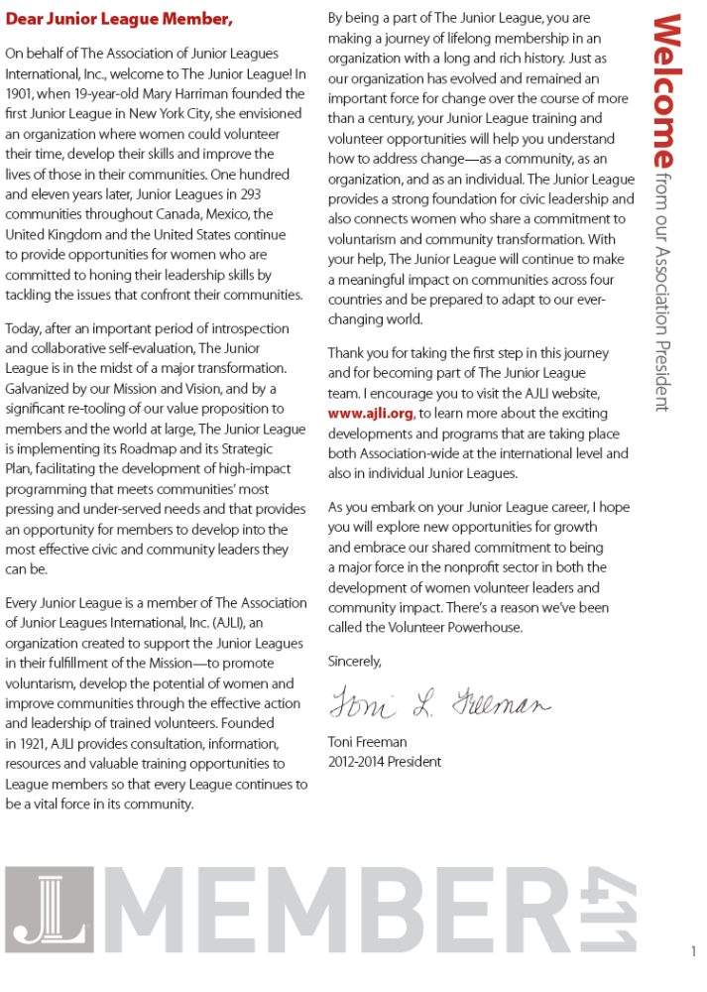
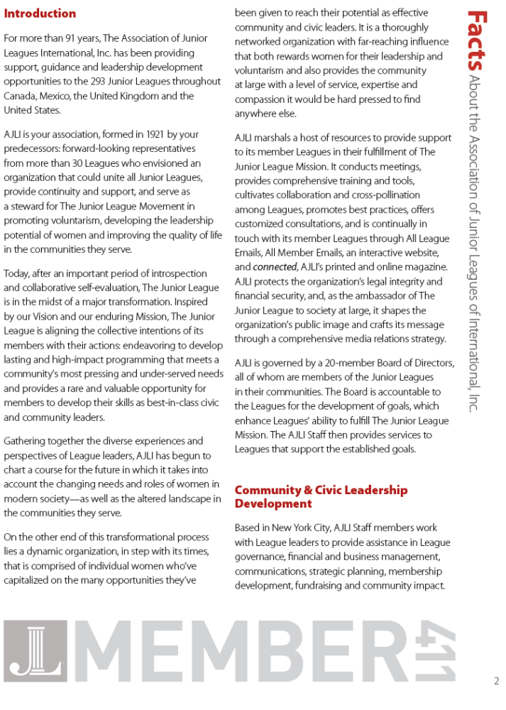
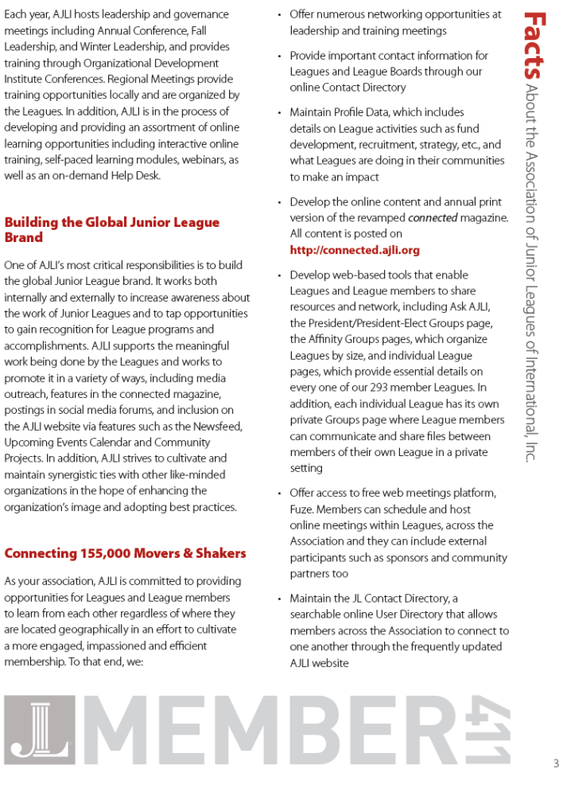
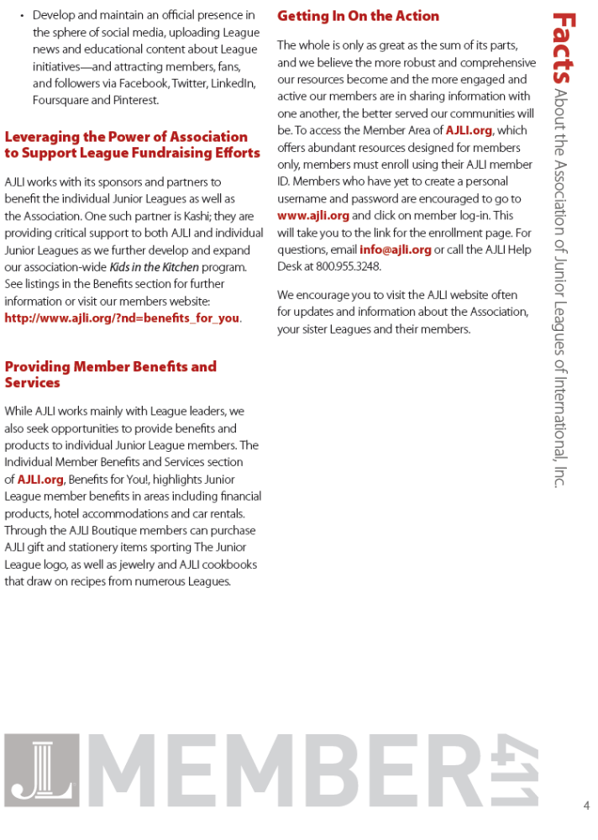
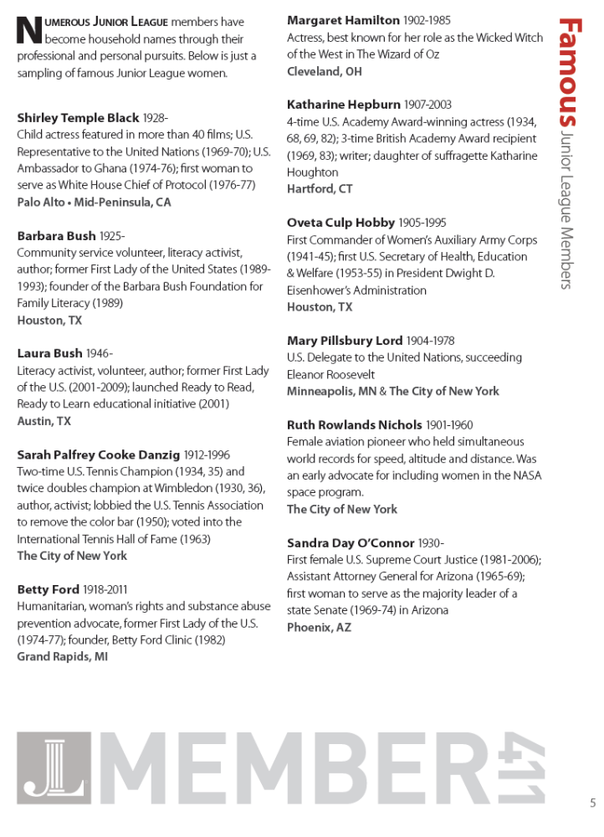
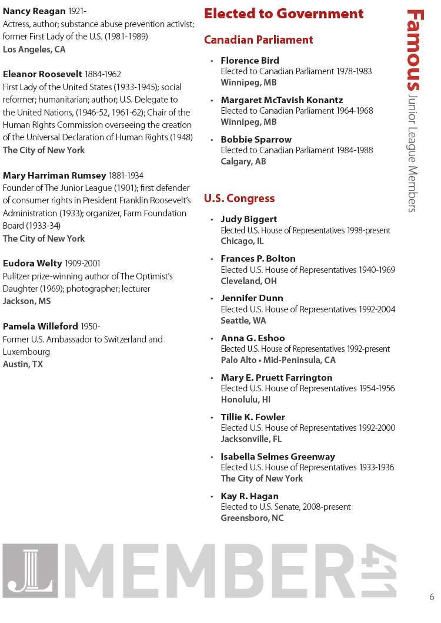
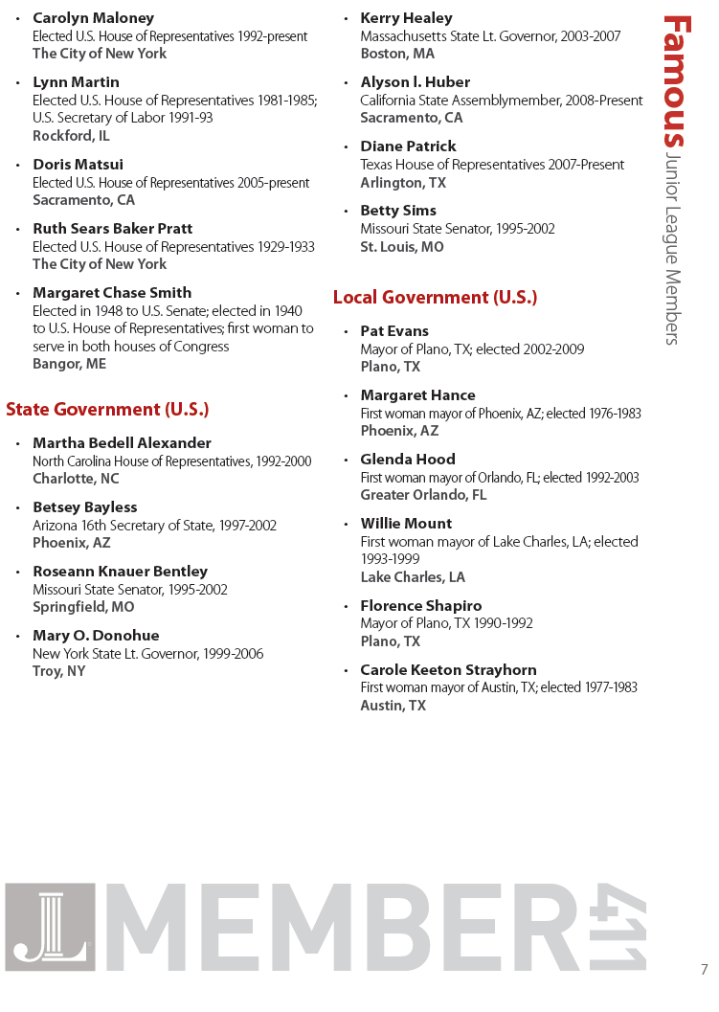
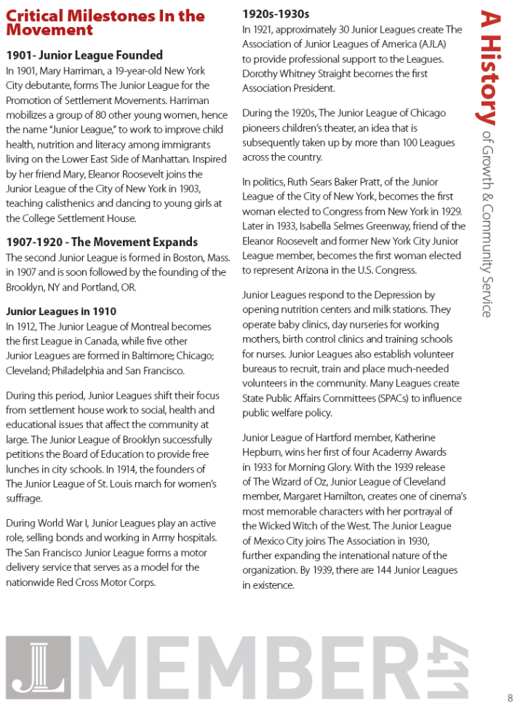
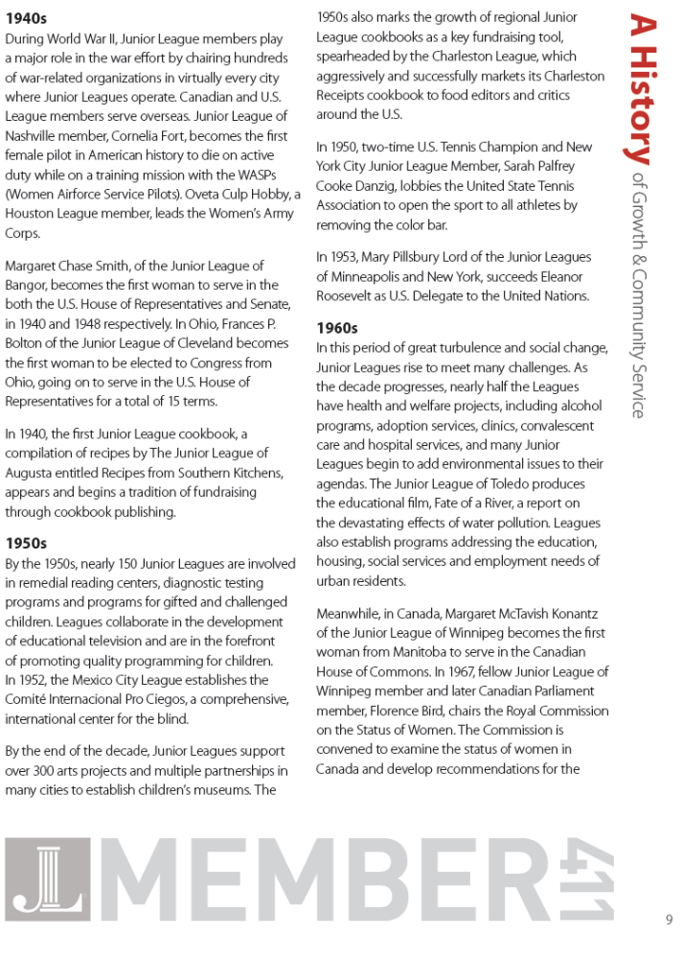
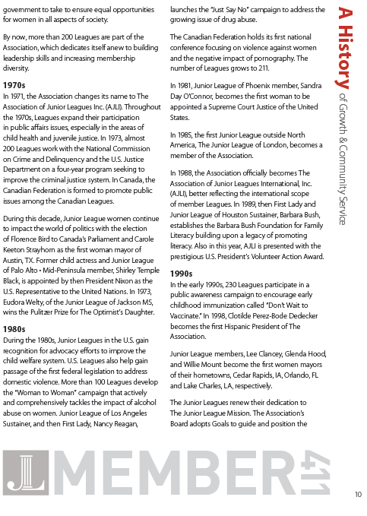
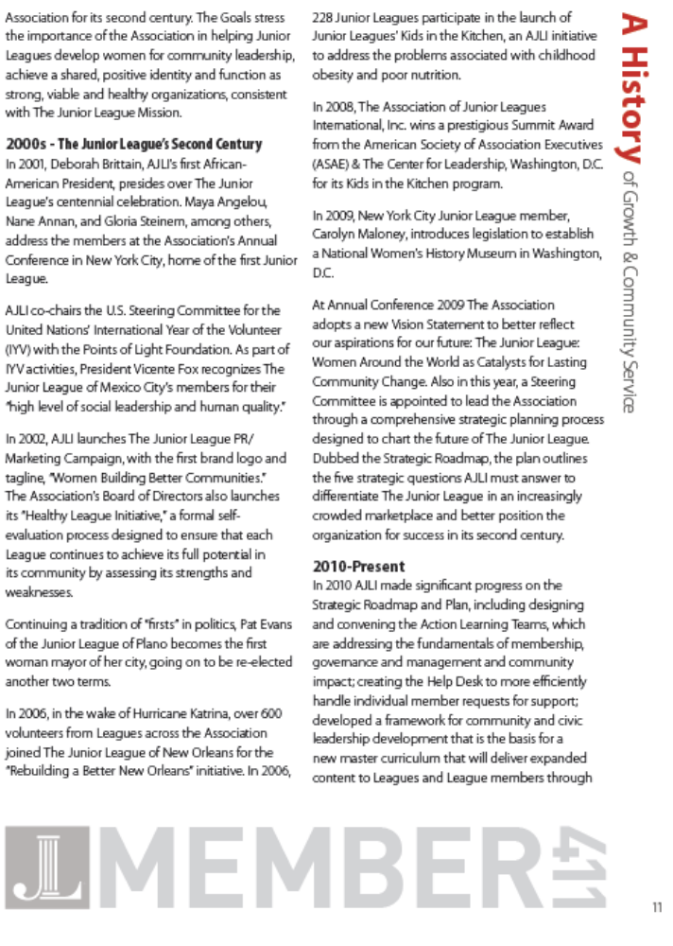
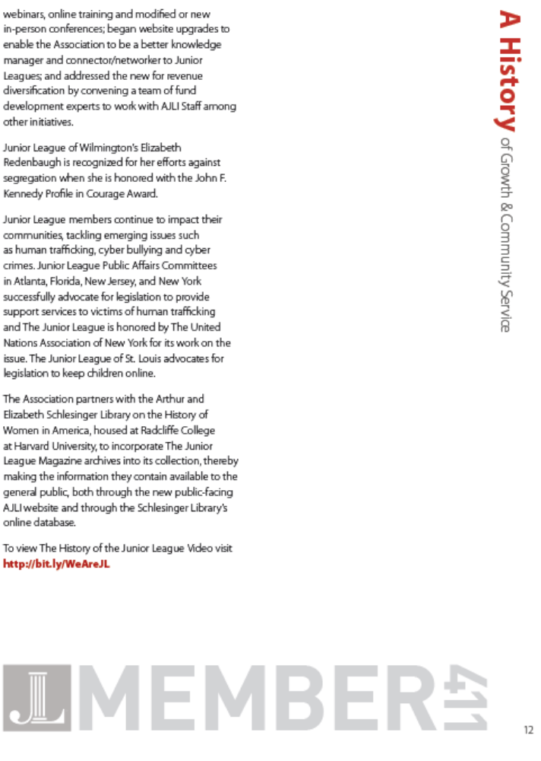
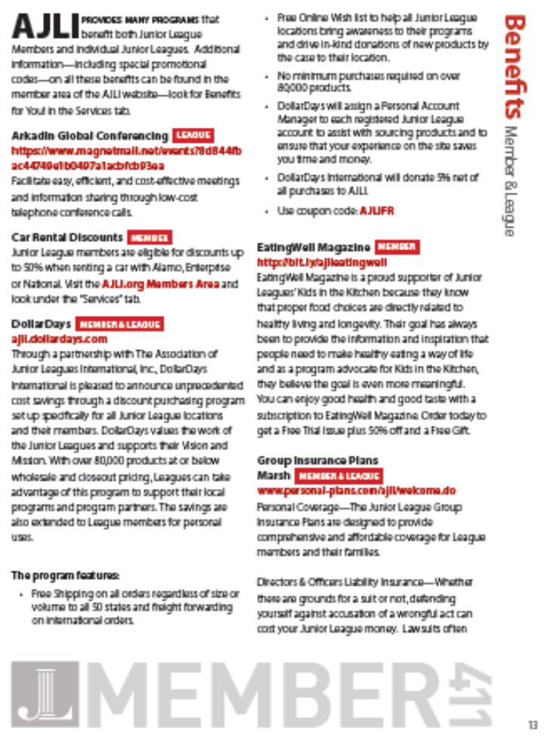
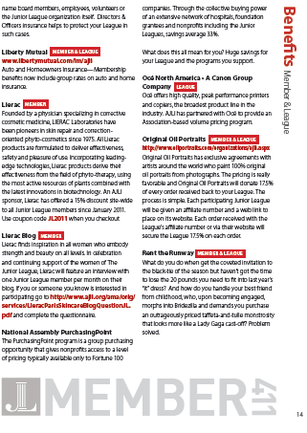
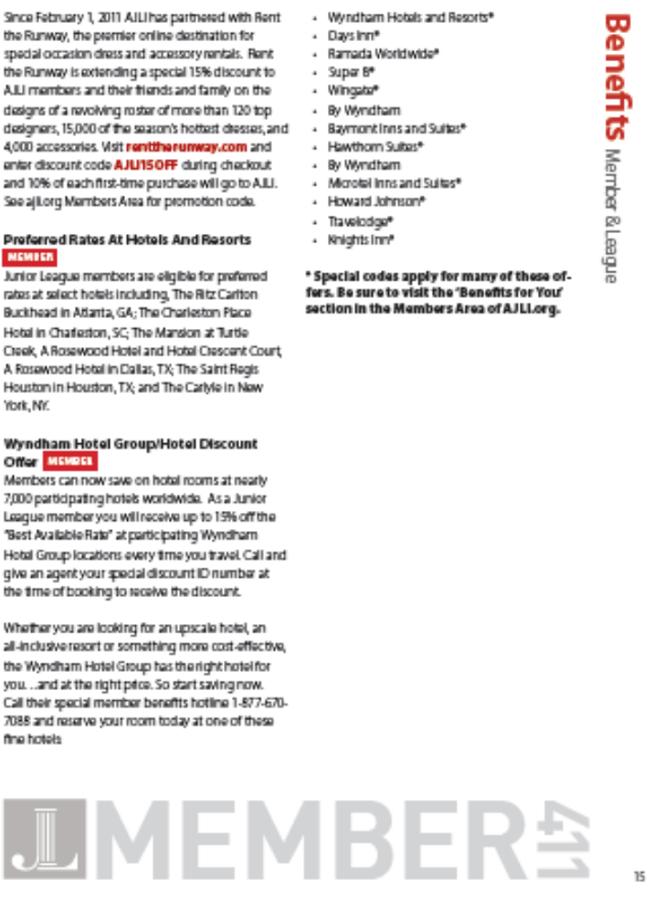
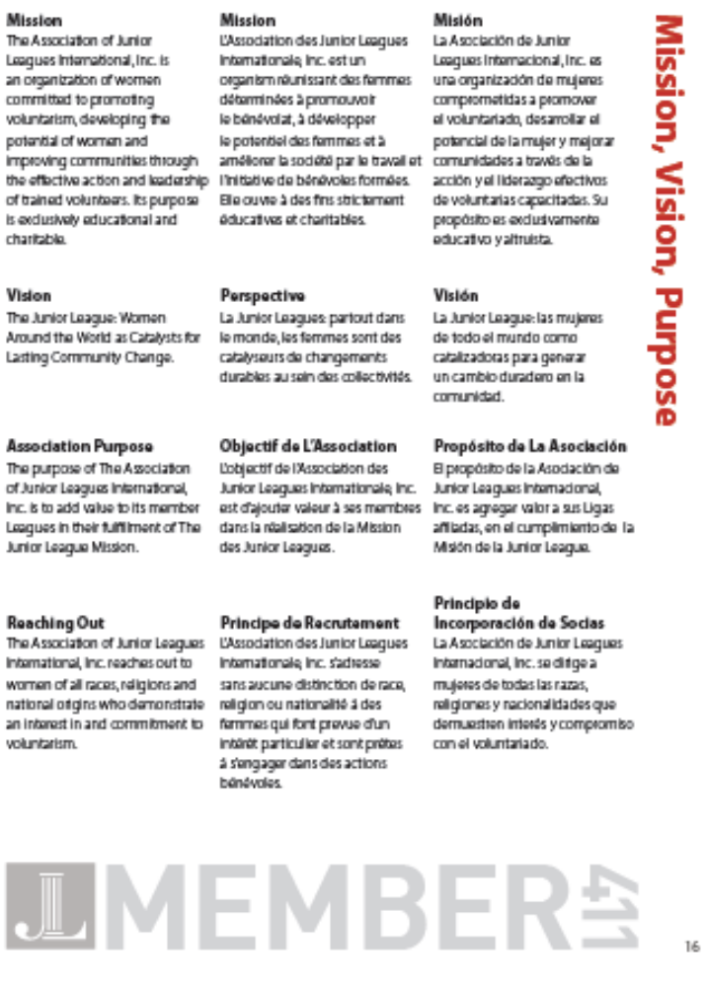
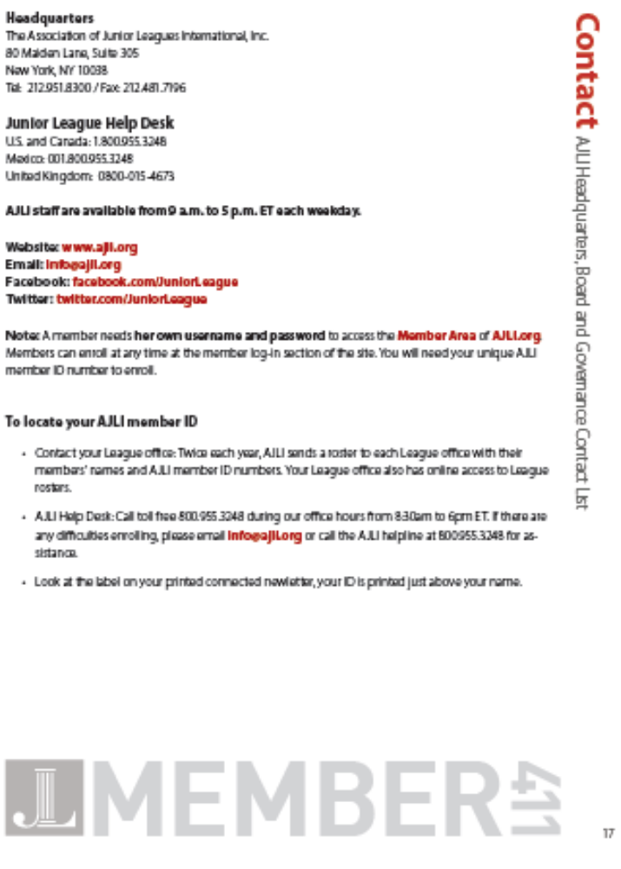
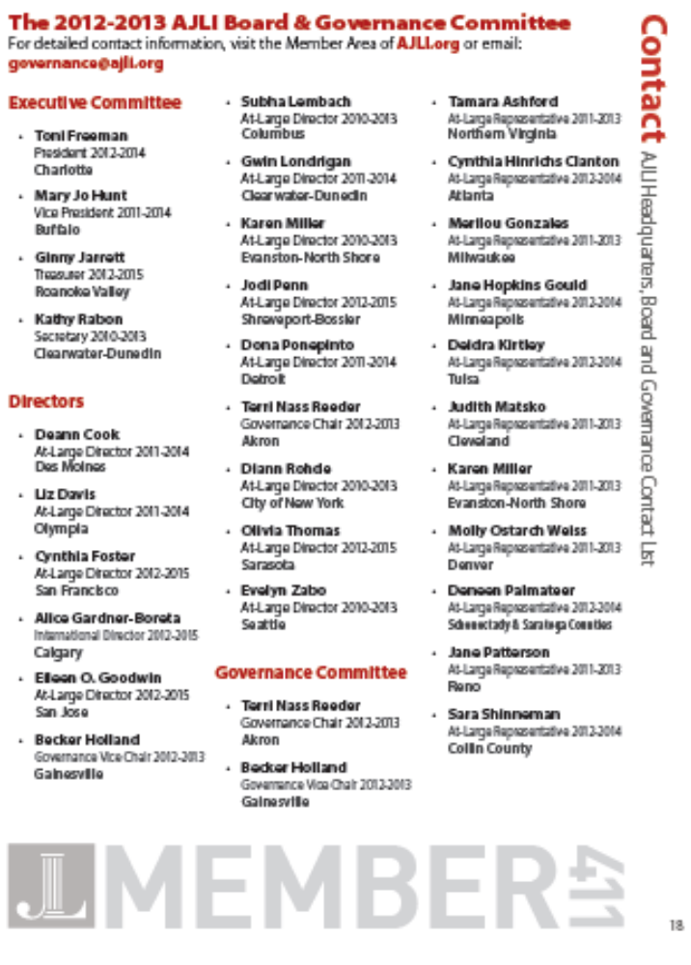
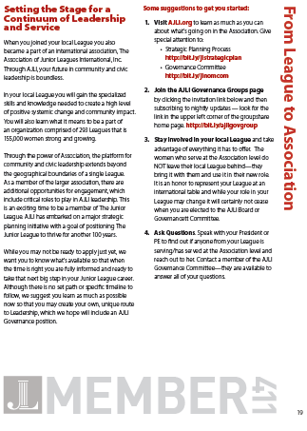
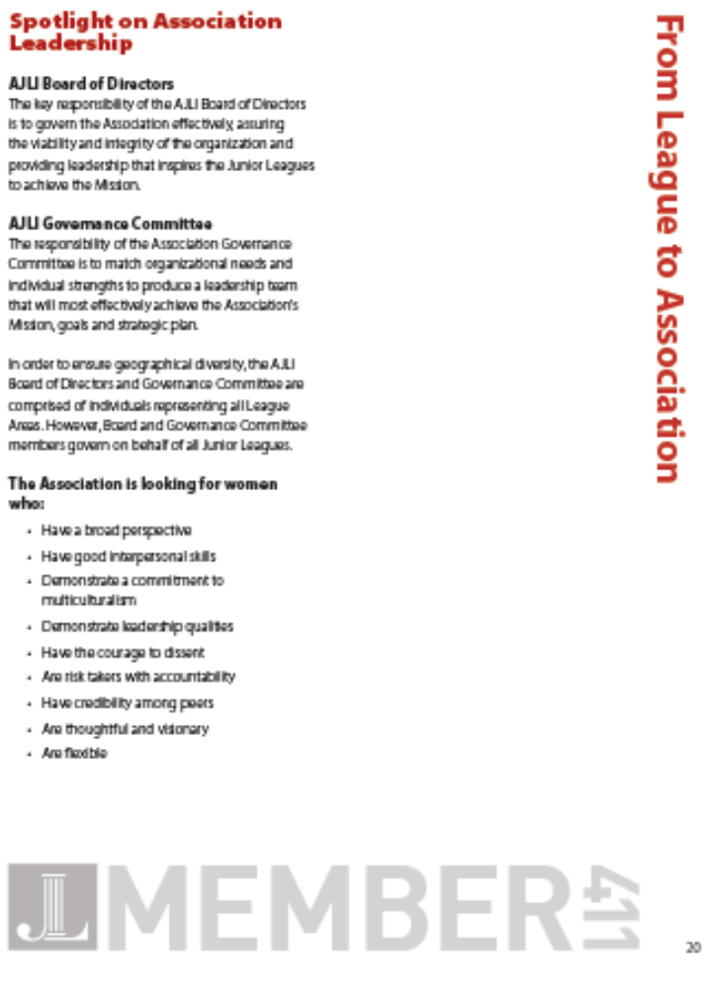
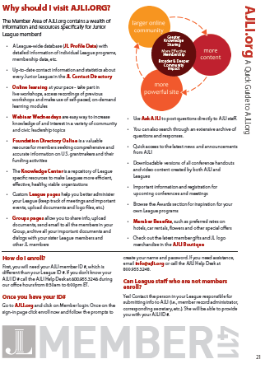

2012-2013 Board Contact Listing

Sandra Doellefeld
President
459-9452 home
577-2785 cell
svdoellefeld@nycap.rr.com

Caitlin Cooper
Treasurer
944-8228
Caitlin.cooper4@gmail.com

Ginny Rosborough
Secretary
(518) 269-2728 cell
ginnylea@gmail.com

Kirsten Kropp (KK)
Community Council VP
(703)314-0253
Kirstenkropp22@gmail.com

Lisa Cronlund
President Elect
439-4448 home
229-2178 cell
Lisacronlund9900@yahoo.com

Evelyn Hickok
Finance Council VP
(518) 373-2320 home
(518) 424-4864 cell
phickok@nycap.rr.com

Jennifer Carraher
Nominating Council VP
(518) 383-5108 home
(518) 312-8682 cell
corpus1024@hotmail.com

Debra Bausback
Sustainer Representative
(518) 512-3058 home
dgb@nycap.rr.com

Linda Barnas
Sustainer Representative
(518) 459-7731 home
Mbarnas1@nycap.rr.com

Who to Contact 2012-2013

Contact the Membership Secretary (Lea Stevens and Brianna Olsen)
- To change a name, address or phone number
- If you are not receiving Capital Connections

Contact the Nominating VP (Jennifer Carraher)
- To change a Membership Classification (transfer, Inter –League, non-resident) (Board must vote before it is finalized)
- To resign in good standing (Board must vote before it is finalized)
- To request a Leave of Absence (Board must vote before it is finalized)
- To request Sustainer Status (Board must vote before it is finalized)

Contact the New Member/ Provisional Chair (Natalia Kokalj, Candace Zlotnick)
- To propose a potential member

Contact the Social and Arrangements Chairs (Michele Gruber and Tara Cristalli)
- If you have a suggestion for a new meeting place

Contact the Training Chair (Colleen Corcoran)
- If you have a speaker or topic suggestion

Contact the Communications VP (please contact Sandra Doellefeld)
- If you have information for a Press Release (at least 15 days prior to desired release date)
- To submit information to the website
- If you have information to publish in the newsletter

Junior League of Albany Membership Requirements

The Junior League of Albany is trying to improve the depth and breadth of its community impact, raise its profile as a successful philanthropic organization, and improve its ability to achieve long term financial viability for its signature projects and other community service activities (i.e. Rockwell Scholarships, community grants, etc). We need the participation of every member to be able to achieve our mission and goals, and to help the broadest spectrum of women and children in the Capital Region as possible. Out of fairness to those members who actively participate in League activities, this year we are seeking to hold all members accountable for their requirements, so the League can continue to grow and improve its impact on our community.

- 2012-2013 Membership Requirements Matrix
Requirements | New members in their 1st or 2nd year of Active service | Members in their 3rd through 5th year of Active service | Members with 6 or more years of Active service
$100 Annual Dues | REQUIRED | REQUIRED | REQUIRED
March Voting Meeting | REQUIRED | REQUIRED | REQUIRED
Placement Fair Meeting (if different from March Voting Meeting) | REQUIRED | REQUIRED | REQUIRED
Other General Membership Meetings Attendance - in addition to March Voting Meeting | 4 | 3 | 2  or  2 additional Community Service Credits
Community Service | 3 | 3 | 3
Financial Requirements | 3 | 2 | 1
American Girl Shift | REQUIRED | REQUIRED | REQUIRED
Committee Participation | REQUIRED | REQUIRED | REQUIRED

- Earning Community Service & Financial Requirements Credits
- Community Service Credit Options
  - 1 Done in a Day = 1 Community Service Requirement - Members must sign in for and complete their entire shift to get credit.
  - 3 Done in a Meetings = 1 Community Service Requirement Credit
  - 3 Community Service Requirement Credits = Outside community service hours equaling 20 hours of service and be presented to the board for approval by the November Board meeting. The request must include contact information for the organizations where community service work is being performed so these efforts can be verified.
  - 1 credit = Sign up 10 children for Imagination Library outside of League sponsored sign-ups
  - 1 Community Service Requirement Credit = Arrange and execute a new DIAD for JLA that is approved by the Board (excludes DIAD Committee)
- Financial Requirements Credit Options (All below are equal to one credit unless otherwise noted)
- Work additional shift at American Girl
- Work one shift or purchase/sell two tickets for a JLA fundraiser event. Note – Shift availability is on a first come, first served basis.
- Recruit a new member to join the Provisional Class.
- Bring a total of 4 non-league members to a fundraising event.
- 3 credits = Buy a table at American Girl
- 2 credits = Participate on a fundraising committee (Excludes Finance Council Members)
- 3 credits = Obtain a corporate sponsor for the League’s signature project (of at least $1,000)
- 3 credits = Obtain individual donations for the League’s signature project (of at least $150 total)
- 3 credits = Sponsor a child for DIL for 5 years ($150)
- 3 credits = Obtain in-kind donations for the League in amount over $500 (i.e. silent auction or raffle donations, advertising space, printing services, free meeting space).
- Option to “buy-out” credits is as follows:
    - 1 credit = $90
    - 2 credits = $120
    - 3 credits = $150

- Ways to Earn Community Service and/or Financial Requirements Credits
- Board participation = 3 community service credits or 2 financial credits
- Committee Chair placement = 2 community service credits or 1 financial credit

- Committee Participation
Each member must actively participate on her committee. The Chair and VPs of each committee will report to the Board monthly on member participation and compliance.

- Accountability & Requirements Management
- It is the responsibility of the League member to ensure that they sign in at meetings and events, as well as to notify placement advisor of any errors in tracking. Any errors must be communicated in writing to the member’s respective placement advisor by no later than March 31 of the League year.
- It is the responsibility of the League member to verify the accuracy of her contact information (such as address, e-mail address, phone numbers) in Closerware, so that the member continues to receive League communications. Any changes in status can be directed to the Membership Secretaries (see “Who to Call” list).
- The placement advisors shall provide a monthly report to the Placement Chair advising on her advisees’ activities and any possible compliance concerns or administrative issues.
- It is the responsibility of members to notify their placement advisor should they be unable to meet the requirements, as stated above, so that alternate plans to meet their requirements can be made.
- JLA will distribute a “Who to Call” list to each JLA member via e-mail, as well at the September GMM, to ensure that all members know who they can call to talk to if they need guidance, to raise a concern, or to advise about any difficulty with meeting membership requirements. This “Who to Call” list will also be filed on the League website.
- Committee Chairs will provide members their committee requirements and it is between the member and chair to determine when requirements have been completed. If a member is unable to meet the committee's requirements, it is the member's responsibility to notify their placement chair in order to request another placement.
- A member’s committee placement participation will not take the place of the Community Service credit requirements. For example, if a member’s committee placement is on the Imagination Library Committee and if that member is required to work a sign-up shift for the IL Committee, that shift does not count as one of the member’s Community Service Credits. The only exception to this is obtaining in-kind donations when the member is on a fundraising committee.

- Sanctions
- Non-Compliance with the American Girl Fashion Show Shift-The American Girl Fashion Show is the League’s largest fundraiser for its signature projects. To ensure it remains a success, we require the participation of every member of the League, without exception.
  - The sanction for not fulfilling the American Girl Fashion Show or making alternate arrangements to fulfill this requirement will be probation and/or a required $250 donation to the League’s current signature project, with a final determination to be made and voted upon by the Board.
  - To avoid invoking a sanction, members unable to be present to work a shift at the AG Fashion Show must advise, in writing, either the American Girl Fashion Show Chairs or a Board member no later than one week prior to the show, so alternative arrangements can be made with that member to fulfill their responsibility in some other way (i.e. writing thank you notes, assisting with assembly of orders, gift bags, inventory, etc).
The Board recognizes that life events happen, and sometimes last minute conflicts arise. If an emergency situation or illness precludes attendance at the member’s shift, the member must call a Board member prior to the start of their assigned shift so arrangements can be made after the show to fulfill requirements.
- Non-compliance with Membership Requirements- Unless special arrangements have been agreed upon between the member, her placement advisor, and the Board, failure to provide significant compliance regarding the League’s membership requirements will result in the member being placed on probation.
- Probation Terms:
Probation can be of short or long term duration, depending upon the nature and severity of the issue. The Board shall determine the length and terms of any probation. Probation terms must be voted upon and approved by the Board, and can include, but are not limited to any of the following terms:
  - Financial sanction- a required donation to the League’s current signature project.
  - Performing additional community service hours.
  - The member will not be able to chair a committee or serve in a leadership position on the Board for one year.
Failure to comply with the probation terms within the specified time period may result in the member being removed from membership not in good standing, contingent upon Board approval.
Placement Listing

President: Sandra Doellefeld Secretary: Ginny Rosborough
President Elect: Lisa Cronlund Treasurer: Caitlin Cooper

Communications Council:
Website: Karen Clark, Bridget Graber, Karen Schiavone
Facebook: Karen Clark, Bridget Graber, Karen Schiavone
Newsletter: Mary-Elizabeth Wightman, Elizabeth Tuttle
Publicity/Marketing: Dafney Amilicar-Rodriguez, Andrea Cass,
Megan Keenholts, Lorayne Pescatore

Finance Council: Evelyn Hickok
American Girl Co-Chairs: Carly Connors, Michele Melton
Fall Fundraiser: Candace Zlotnick
Holiday Party: Felice Devine, Kelly Haseotes, Kelcie Racino
Grants: Naomi Shencavitz, Meghan Keating, Ginny Rosborough

Finance Committee Members: Carolyn Daggett, Sarah Kenning, Janis Graziano, Naomi Shencavitz, Lynn Roberts, Lauren Paulk, Lea Stevens

Membership Council:
Provisional Chairs: Natalia Kokalj and Candace Zlotnick
Provisional Committee: Maggie Dunham, Meghan Keating
Training Committee: Colleen Corcoran, Sharon Lastique, Cristina Commisso
Social & Arrangements: Michele Gruber, Tara Cristalli
Membership Council: Kelly Haseotes

Community Council: Kirsten Kropp
Imagination Library Chairs: Kate Barry, Jennifer Bryant
Imagination Library Committee: Eileen Smith, Elizabeth Tuttle, Cristina Commisso, Mandy Nordstrom, Kelcie Racino, Amy Smith
Rockwell Scholarship Chair: Felice Devine
Rockwell Scholorship Committee: Janis Graziano, Lauren Paulk
DIAD Chair: Michele Melton
DIAD Committee: Lakisha Rich, Michele Gruber, Megan Kelly, Taryn Davila-Webster, Stacey Stump, Brianna Wattie-Olsen

Nominating Council: Jennifer Carraher
Nominating Committee (members are selected by their peers & asked to be on this committee): Lakisha Rich, Natalia Kokalj,
Placement Chair: Sarah Kenning

Membership Secretary: Brianna Wattie-Olsen, Lea Ermides Stevens

Women Of Distinction Chair: Jennifer Carraher
Committee: Candace Zlotnick, Megan Kelly, Janis Graziano, Taryn Davila-Webster

95th Anniversary Committee: Natalia Kokalj, Janis Graziano, Bridget Graber, Rachel Hajos

Exploratory Committee: Lea Ermides Stevens

JOB DESCRIPTIONS

President
- Serves as the chairwoman of the Board of Directors Meetings
- Oversees In-League administration and coordinates all League activities.
- Presides at Board, Membership and Community Advisory Board meetings.
- Serves on the Strategic Planning Committee.
- Orients the President-Elect to the duties and responsibilities of the Presidency.
- Serves as liaison to AJLI and other Junior Leagues, attends AJLI Annual Meeting and is the “A” delegate to the AJLI Annual Conference.
- Screens public relations (all public announcements, press statements, contacts, brochures’, etc.) for the League.
- Appoints chairs not otherwise provided for and special or ad-hoc committees.
- Directs and participates in Board/ Council Discussion.
- Organizes the annual Board retreat (Discussion of long range plan for the League and reviews possible changes in League goals, basic policy, Board structure and committee functions.)
- Directs and coordinates goal setting with Council VPs for inclusion in Annual Plan and presentation to General Membership.
- Represents the League at Community functions.
- Primary contact with the League attorney and grants permission to members to consult League attorney when needed.
- Oversees development and implementation of three-year financial plan, with the Finance Council VP.
- Reviews focus areas every three to five years.
- Summarizes annual reports submitted by each Council and submits a summary to be included in the Redbook.

President-Elect
- Assumes the duties and exercises the power of the President in her absence.
- Leads and manages the Strategic Planning Committee which consists of the President, Past President, League Communications VP, Community VP, Membership VP, and Nominating VP. Assist the Board in annual definition of the overall League program and priorities.
- Serves as the Parliamentarian for the League: these duties encompass:
  - Reviews all Bylaws, Policies and Standing Rules and proposed amendments.
  - Presents background information for Bylaws changes.
  - Keeps updated copies of JLA and AJLI Bylaws.
  - Checks with the League attorney regarding any changes proposed to the Bylaws.
  - Tallies votes for the election of Nominating Committee members and forwards them to the Nominating Vice President.
- Reviews and disseminates information from AJLI Area I and other Leagues to the appropriate councils or committees.
- Serves as a liaison to AJLI, Area I and other Leagues and:
  - Communications with Area Council and shares information on League projects, fundraisers, programs, policies, etc.
  - Makes and coordinates requests to the Area Recourse Center on behalf of the League.
  - Submits requested materials to AJLI, Area I office, Area Director, Director-at-Large and Area Nominating Committee.
  - When available, administers AJLI Questionnaire- coordinates information gathering, checks for accuracy.
  - Attends the AJLI sponsored President- Elect meeting.
- Oversees the transition of Board and Committee notebooks and responsibilities.
- Attends at least one meeting of the other Councils.
- Complies and disseminates the results of the Albany Junior League Questionnaire when necessary.
- Is responsible for reviewing with Finance Council Director the financial viability of the League fundraisers for the following year with possible recommendation to President of forming an ad-hoc committee to investigate potential future fundraisers.
President Elect-Elect
- Attends AJLI President Elect-Elect training meeting.
- Serves as Placement chair.

Past President
- Serves on the Strategic Planning Committee.
- Attends Community Advisory Board meetings.
- May serves as an n advisor to the Nominating Committee.

Community Advisory Board
- Members are selected by the President for a rotating two-year term to enhance League’s mission and focus. League members include Past President, President-Elect and Recording Secretary.
- Advises on current and proposed projects.
- Recognizes community trends and needs.
- Identifies community recourse, issues and the potential for coalition building.
- Enhances the community understanding of the Junior League of Albany, Inc. its purpose, professionalism and commitment to improving the community.

Secretary
- Keeps minutes of all Board, General Membership, and Community Advisory Board meetings and distributes to membership on timely basis.
- Has change of attendance, League records, corporate seal and binding of minutes.
- Directs the mailing of the minutes and motions to the Board of Directors.
- Tallies all votes at membership meetings.
- Is responsible for all official League correspondence from the Board.
- Working with President, prepares and disseminates pre-Board mailing, including agenda, minutes, Membership Report, Council Reports, flavors of the month and other information.
- Working with the President, prepared pre-General Membership mailing, including agenda, minutes, Membership Report, and other information as needed for General Membership meetings.
- Distributes meeting minutes to Webmaster for inclusion on the website.
- Serves on the Board of Directors.

Treasurer
- Is responsible for administration of main League accounts and for ensuring that receipts are deposited and disbursements are made and accounted for on a timely basis.
- Reports monthly financial transactions to Bookkeeper and Board on a timely basis.
- Oversees adherence to the League’s Budget and monitors expenses and accumulation of revenues.
- Works with the Board on the education of the membership concerning financial matters
- Serves on the Board of Directors
- Debit Card responsibility, shared with President and Assistant Treasurer as well.
- Makes recommendations for removal of members for non-payments of dues at June Board meeting.
- Submits an annual report to the Communications VP by the April Board meeting that summarizes her Council/ Positions activates during the past League year.
- Serves as the custodian of the JLA funds.
- Coordinates with bookkeeper to prepare monthly Financial Statements. Presents monthly budget to the Board and General Membership.
- Is responsible for the development and adherence to the League’s annual budget and financial forecasting.
- Oversees adherence to League Budget and monitors expenses and accumulation of revenues.
- Responsible for the coordination of the annual audit or review and dealings with the accountants.
- Reviews and files all insurance policies and annual contracts and makes recommendations regarding them.
- Responsible for the development and implementation of the 3 year financial plan.

Assistant Treasurer
- Sends dues notices by February 1 and sends overdue notices to members who have not paid by April 15 with one additional follow up letter notifying members who have not paid of impending removal.
- Works with Treasurer to learn the position for next year.
- Fills in for Treasurer at Board meetings if she cannot attend.
- Debit Card responsibility, shared with President and Treasurer as well.

Fund Development
- Presides at Fund Development meetings.
- Submits annual goals and objectives for her Council.
- Serves of the Board of Directors.
- Is responsible for communicating Council matters among the membership, Council and Board of Directors.
- Submits an annual report to the Communications VP by the April Board meeting that summarizes her Council/ Positions activates during the past League year.
- Is responsible for reviewing with President-Elect and Treasurer the financial viability of the League fundraisers for the following year.
- Is responsible for communicating Council matters among the membership, Council and Board of Directors.
- Submits annual goals and objects for her Council that reflect those approved by the General Membership to be in effect for that League year.
- Submits an annual report to the Communications VP by April Board Meeting that summarizes her Council’s activates during the past League Year.

Communications Council Vice President
- Presides at all League Communications Council meetings
- Leads and manages the League Communications Council which consists of Publications Committee and Public Relations/ Publicity Committee.
- Develops and executes Public awareness campaigns that communicate League’s strategic vision.
- Develops opportunities to promote the League both internally and externally to increase awareness, interest and knowledge of the League and its many activities.
- Provides a consistent message to the community.
- Reviews any public items before release and communicates changes/ approval to PR Chair and President.
- Responsible for maintenance of JLA website in coordination with the Webmaster.
- Serves on the Strategic Planning Committee.
- Is responsible for communicating Council matters among the membership, Council and Board of Directors.
- Submits annual goals and objectives for her Council.
- Compiles annual report.
- Serves on the Board of Directors.

Public Relations/Publicity Chair
- Serves on the Communications Council
- Chairs the Public Relations/ Publicity Committee which:
  - Develops the annual public relations, collateral material and publicity plan and oversees it implementation.
  - Works with media representative to Increase League visibility.
  - Develops and distributes public relations materials.
  - Maintains an up-to-date scrapbook of all League publicity.
  - Creates and distributes press releases, public service announcements and arranges press conferences and interviews as needed. Sends al written material to Communications VP and President for prior approval.
  - Is responsible for ensuring that League promotional materials (including JLA display, brochures, etc.) are at all League events.

Publications Chair
- Serves on Communications Council.
- Chairs the Publications Committee which:
  - Publishes and distributes the Capital Connections.
  - Maintains financial self-sufficiency of Capital Connections publication by soliciting patrons and advertising support.
  - Updates the JLA Redbook and distributes it at the September General Membership meeting.
  - Produces the JLA Annual Report.

Membership Services Vice President
- Presides at all Membership Services Council meetings
- Leads and manages the Membership Services Council which consists of the Training Committee, Social/ Arrangements Committee, New Member Committee and Membership Secretary.
- Plans presentations and gift purchases for members approves for Sustainer status for award at the May dinner meeting.
- Ascertains former members’ interest in rejoining the League.
- Serves on the Strategic Planning Committee.
- Responsible for researching and developing membership recruitment and retention programs.
- Coordinates membership mentorship programs in coordination with Training Chair.
- Serves on the Board of Directors.
- Is responsible for communicating Council matters among the membership, Council and Board of Directors.
- Submits annual goals and objectives for her Council by October Board Meeting.
- Submits an annual report to Communications Council VP by April Board meeting that summarizes her Council’s activity during the past year.

Provisional Committee Chair
- Serves on Membership Council.
- Chairs the Provisional Committee which:
  - Recruits new members, training class, educating Provisional members for active League participation; training to include membership requirements.
  - Presents and recommends Provisionals to Board of Directors for Active membership.
  - Hosts Open House and other opportunities to let the community know about the League and invite them to join.

Transfer Chair
- Serves on Membership Council
- Provides Information about upcoming meetings and events.
- Provides member with Membership Directory, website access information and newsletter.
- Introduces new member at General Membership Meeting.

Training Chair
- Serves on Membership Council.
- Chairs the Training Committee which:
  - Develops and presents relevant, mission- focused training program for League members in consult with the President.
  - Supervises continued use and teaching of AJLI training programs.
  - Works with Provisional Committee Chair to train provisional and new transfer members.
  - Researches and organizes training for the membership.
  - Develops curriculum that is relevant to our membership and to our focus area.

Membership Secretary
- Serves on the Membership Council
- Maintains the League on-line database:
  - Make changes to contact information for those that do not have e-mail addresses (i.e. do not have an on-line account)
  - Update Membership statuses at the direction of the Board.
- Emails database reports, membership spreadsheets, and/or mailing labels to members as needed.
- Submits monthly Membership Report to the Membership VP highlighting changes to membership status or contact information; transfers in/out of the League; and congratulations or condolences information.
- Compiles annual Membership Report inclusive of all changes for distribution at the Annual Meeting.
- Communicates resignations, leaves of absence, and sabbaticals to Membership VP for communication to the Board for a vote.
- Processes transfers both in and out of the League and communicates arrival of transfers to the New Member Chair, Placement Chair, or Sustainer Representatives.
- Synchronizes database with AJLI records on a regular basis, and particularly when AJLI sends the annual Billing notice.
- Sends congratulation, condolence, and acknowledgement cards and/or flowers on behalf of the Membership at the request of the Board.

Social and Arrangements
- Serves on the Membership Council.
- Arranges details of the General Membership Meetings (Reservations, location, refreshments and equipment).
- Works with other committees as needed.
- Enlists hostesses for Feb Sectional Meetings.
- Emails the evites to the membership for the monthly GMM meetings, checking to make sure that the evites are going to the proper members.
- Invites Sustainer Bowl winners to the May Dinner Meeting.
- Invites Community Advisory Board to September and May General Membership Meetings.

Community Council Vice President
- Presides at all Community Council meetings
- Leads and manages the Community Council
- Is responsible for Community Research and Project Development, which:
  - Surveys the League to determine areas of interest in potential projects within prescribed focus areas.
  - Researches community in areas of League interest to determine community need.
  - Initiates interest groups, which develop potential projects according to project criteria.
  - Evaluates ongoing projects according to evaluation timetable built into each project timetable.
  - Notifies membership of community volunteer opportunities as they arise.
- Is responsible for Grant Analysis and Distribution, which:
- Reviews all grant requests submitted to the League.
- Distributes grants funds to the community when available.
- Communicates to Grant recipients the announcement of grants.
- Is responsible for the Scholarship Fund grants when available.
- Is responsible for other Community Projects within the Focus Area, which:
- Administers the program or activity of the membership –approved project.
- Reports regularly to membership and the Community Council on project status, finances and activities.
- Reviews project proposal(s) before they are brought to the League for a vote.
- Serves on the Strategic Planning Committee.
- Serves on the Board of Directors.
- Submits annual goals and objectives for her committee by October Board meeting that reflect those approved by the General Membership to be in effect for that League year.
- Submits an annual report to Communications Council VP by April Board meeting that summarizes her Council’s activity during the past year.
Imagination Library
Rockwell Scholarship
Done in a Day

Nominating Vice President
- Leads and manages the Placement/ Nominating Committee.
- Is responsible for Nominating, which:
- Develops, promotes and provides leadership to the Albany Junior League, Area I, AJLI and the community.
- Slates the Board of Directors and Council members and replacements should a vacancy occur.
- Coordinates the selection of members for ODI training opportunities and submits a list of members to the Board for approval.
- Serves on the Strategic Planning Committee.
- Serves on the Board of Directors.
- Is responsible for communicating committee matters among the membership, Council and Board of Directors.
- Submits annual goals and objectives for her committee by October Board meeting that reflect those approved by the General Membership to be in effect for that League year.
- Submits an annual report to Communications Council VP by April Board meeting that summarizes her Council’s activity during the past year.

Placement Chair
- Arranges and conducts annual interviews and organizes follow-up contacts with all Active and Provisional members.
- Guides members in finding their placement and notifies members of community volunteer opportunities as they arise.
- Communicates individual member League requirements.
- Helps members meet League requirements and records their fulfillment. Keeps a record of individual member’s activities, interests and experiences.
- Conducts an exit interview for each resigning member.
- Contacts committee chairs regarding committee members’ work at mid-year. Follows-up where problems arise or are noted.
- Places members on committees by early May.

Sustainer Representatives
Sustainer Chairs (2 year rotating position)
- Serve as the voting representative for the Sustainers to the Board of Directors. Co-chairs will determine who will attend these meetings, or can elect to attend together, but there is only one vote. (If neither chair can attend, a designee should attend)

- Assist in the recruitment of Sustaining members to serve as advisors to committees and councils as requested by the Active Board

- Coordinate and submit articles to the Capital Connections chair on a monthly basis (or whatever publication schedule is determined by the Communications Council). Also submit article for the year-end Annual Report to members.

- Submit monthly Board report prior to each Board of Directors meeting.

- Coordinate submission of Sustainer Activities to webmaster for listing in the Sustainer section of the JLA website.

- Organize the Sustainer Group that meets regularly (2nd Tuesday of the month as needed) by setting the agenda, presiding over the meetings, taking minutes, and determining meeting locations. (Traditionally the 2nd year representative chairs the meeting, and the 1st year representative takes the minutes.

- Maintain relationship building and proper communication with sustainers through appropriate mechanisms.
- Welcome JLA members as they move from Active to Sustainer status, as well as welcoming returning and transferring Sustainers.
- Encourage recruitment of lost sustainers
- Coordinates updates of sustainer contact information; including providing the VP Communications with a list of sustainers with “no e-mail”

- Members of the Sustainer Bowl selection committee (see Sustainer Bowl procedures booklet for details). If a representative is unable to be a part of this committee, another Sustainer must be appointed to fill this position. Attend the Annual Meeting of the Junior League of Albany in May and present the Sustainer Bowls

- Represent Sustainers at Sustainer events and all-League events as necessary. Agendas and remarks should be developed for luncheon/dinner events; thank chairs at social events.

- Attends League functions and encourages participation by Sustainers where applicable.

- Prepares an annual Report to be included the JLA board annual report document.

- Recruit potential members into Provisional status

- Contact sustainers who are delinquent in paying their dues to encourage their remittance or other membership change (such as transfer or resignation in good standing) if necessary.

- Provides support to JLA board on matters of governance, administration and training.

- Arranges for the Spring“Provisional Party”, including the “new” actives, old/new JLA active board, Provisional committee, and sustainer group.

Junior League of Albany, New York Bylaws

As amended and restated on October 11, 2011. A Not-for-Profit Corporation of the State of New York.

ARTICLE I. NAME
The name of this organization shall be The Junior League of Albany, New York,
Inc. (hereinafter sometimes called “the League”)

ARTICLE II. PURPOSE, POLICIES AND STANDARDS
Section 1. Mission and Purpose:
The Junior League of Albany, New York Inc. is an organization of women
committed to promoting voluntarism, developing the potential of women and
improving communities through the effective action and leadership of trained
volunteers. Its purpose is exclusively educational and charitable.

Section 2. Policies:
The policies of the League shall be in harmony with the policies of the
Association of Junior Leagues International Inc. (hereinafter sometimes called
“the Association).

The League reaches out to women of all races, religions and national origins who
demonstrate an interest in and a commitment to voluntarism.

The League does not discriminate on the basis of race, religion or national origin.

All meetings and functions of the League shall be held at facilities which do not
discriminate against women or on the basis of race, religion or national origin.

The books and accounts of the League shall be kept in accordance with
generally accepted accounting principles and shall be audited or reviewed
annually by a certified public accountant or the international equivalent at the end
of the fiscal year.

The League shall immediately send to the Association office evidence of any
change in its status as a tax exempt organization under section 501(c)(3) of the
U.S. Internal Revenue Code.

Section 3. Administrative Standards
The League shall maintain the same standards as are required of groups
applying for membership in the Association pursuant to the Association’s Bylaws.

Code of Conduct
All Junior League of Albany members are expected to conduct themselves in a legal, ethical, moral, responsible and respectful manner at all activities and events, as well in internal and external communications related to the Junior League of Albany. This includes League-sponsored events, events sponsored by community partners of the Junior League of Albany and any activity and communications in which members represent the organization.

League members shall only speak on behalf of the league - in person or in any type of written or electronic format of any type currently in existence or developed in the future - when they are acting in the capacity of their League placement and with authorization of the League President or her designee.

ARTICLE III. MEMBERSHIP
Only women who comply with the requirements of the Association and this
League shall be admitted to Provisional Membership by this League. No
member shall at any one time be a member of more than one Junior League.

The Board of Directors shall, from time to time, adopt policies regarding the
rights, roles and responsibilities of membership in the League. Said policies shall
be subject to approval by a two-thirds affirmative vote of the members entitled to
vote thereon.

Section 1. Categories of Membership
The Categories of Membership shall be as follows:
A. Provisional Membership
Provisional members are those members who are engaged in training
established by the Junior League of Albany to prepare them for effective
community and League involvement.
B. Active Membership
Active members are those members who have completed Provisional
training and justify Active membership by demonstrating volunteer service
to the community and the League as defined by the Junior League of
Albany.
C. Sustaining Membership
Sustaining members are those members who have fulfilled the Active
membership requirements as defined by the Junior League of Albany and
who continue to support the League and its community.

Section 2. Admission to Membership
A. Eligibility
Before accepting an invitation to membership, proposed members
shall have received an orientation in the privileges and
responsibilities of League membership, and shall agree to engage
in community service in connection with the program of the League.
1. Age
Proposed members shall not be less than 21 years of age.

2. Residency
a. Resident Prospective Member
A resident prospective member must live or work
within 50 miles of the City of Albany at the time of her
application.

b. Nonresident Prospective Member
A nonresident prospective member must live within
another League’s area at the time of her application
and must have lived away from the Albany area for
more than five years immediately preceding the
deadline for turning in applications.

3. Other Criteria
a. Interest in voluntarism.
b. Commitment to community service.
c. Interest in developing her potential for voluntary
community participation.

B. Proposal for Membership
The Board of Directors shall, from time to time, adopt policies
governing the admission of prospective members. Said policies
shall be subject to approval by a two-thirds affirmative vote of the
members entitled to vote thereon.

C. Admission to Active Membership
After successfully completing the Provisional course, Provisional
members shall be approved for Active Membership by a majority
vote of the Board of Directors. The names of the newly elected
members shall be announced at the next membership meeting of
the League following their approval.

Section 3. Privileges of Membership: Transfer, Inter-League, Seasonal and Non-
Resident Transfer
Any Provisional, Active or Sustaining member in good standing of the League
may transfer membership to another Junior League. A member who transfers to
another Junior League shall be granted the status consistent with the
specifications of membership categories of the receiving Junior League. A
Provisional member who transfers has the right to complete the training for
effective community and Junior League involvement as determined by the
receiving Junior League.
The Board of Directors of the Association shall from time to time adopt written
policies governing the privileges of membership including transfer, inter-League,
seasonal inter-League non-resident and non-resident transfer privileges. Such
policies shall be subject to the approval of the Junior Leagues.

Section 4. Resignations
Any member of the League who is not in arrears in dues or in the performance of
League duties may resign in good standing.

Section 5. Removal
A. Any member may be suspended or removed by a two-thirds
(2/3) vote of the Board of Directors after at least fifteen (15) days
notice in writing to the member, stating the cause for such action.
Except in cases of non-payment of dues, an opportunity for a
hearing before the Board shall be given.
B. Members who fail to pay dues by July 1 shall be removed
from membership.

Section 6. Reinstatements
Members who have resigned in good standing may apply in writing to the Board
of Directors for reinstatement. They may be reinstated by a two-thirds (2/3) vote
of the Board of Directors upon paying the current dues.

Article IV. Dues and Other Financial Obligations
Section 1. Dues
The Board of Directors shall from time to time establish policy concerning the
amount of dues to be paid by each member. Such policies shall be subject to
the approval by a two-thirds affirmative vote of the members entitled to vote
thereon.
There shall be an automatic increase in the dues of the Junior League whenever
the Association, through its delegate body, approves a dues increase at the
Association's Annual Meeting. The amount of the automatic increase shall be
equal to the amount of the increase in the Association dues and shall take effect
the same fiscal year in which the Association increase takes effect.

Section 2. Refunds
There shall be no refunds of dues made to members resigning or removed during
the League year, nor to Provisional members who fail to meet the provisional
requirements.

Article V. Officers
Section 1. Officers
The officers shall consist of at least the President and Recording Secretary.
Additional officers can be named by a two-thirds (2/3) affirmative vote by the
Board of Directors.

Section 2. Duties
The powers and duties of the officers shall be as follows:
A. President
The President shall be the chief executive officer of the League and
shall perform the duties usually pertaining to the Office of
President. She shall preside at meetings of the League and Board
of Directors, and shall be a member ex-officio of all committees and
councils except the Nominating Committee. The President shall,
with the approval of the Board, appoint other committees, make
other appointments not otherwise provided for, and shall perform
such other duties as may be assigned by the Board of Directors.

B. Secretary
The Secretary shall give, or cause to be given, notice of all
meetings of the League and the Board of Directors and shall be
responsible for the keeping of all minutes of such meetings. The
Secretary shall be responsible for the custody of the seal of the
League and the affixing of same. The Secretary shall be in general
charge of the records of the League, other than financial records,
and shall perform such other duties as may be assigned by the
Board of Directors.

Section 3. Eligibility
Any Junior League of Albany New York member in good standing, who is an
Active member, as defined in these Bylaws, as of the deadline for nominations,
except a Nominating Committee member, shall be eligible to serve as an officer
of the League.

Section 4. Election and Term
The Nominating Committee shall slate one candidate for each officer position.
All officers will serve a term of one year, to commence at the close of the Annual
Meeting. In the event no successor is elected, an officer shall continue to serve
one additional term or until a successor is named, whichever occurs first. Notice
of the slate shall be sent to all Active and Provisional members of the League at
least 30 days prior to the election meeting.

Section 5. Additional Candidates
Independent nominations may be made, in writing, by at least ten (10) Active
members and with the written consent of the nominee. Independent
nominations must be received by the Nominating Chair no later than 14 days
after the slate has been sent to the membership. No more than 72 hours upon
receipt of an independent nomination, the Nominating Chair shall notify the
membership.

Article VI. Board of Directors
Section 1. Duties
The governing body of the League is the Board of Directors, which has authority
and is responsible for the governance and management of the League. The
Board sets strategic outcomes, establishes policy and monitors implementation
of policy consistent with these Bylaws and with the Junior League Mission.

Section 2. Composition
The Board of Directors consists of the President, President-Elect, Recording
Secretary and up to five (5) Council Directors. The actual number of Council
Directors at any given time, their titles and duties shall be based on the Board’s
determination of the Council structure.

Section 3. Eligibility
Any Junior League of Albany New York member in good standing, who is an
Active member, as defined in these Bylaws, as of the deadline for nominations,
except a Nominating Committee member, shall be eligible to serve as a Council
Director of the League.

Section 4. Election and Term
The Nominating Committee shall slate one candidate for each Council Director
position. All Council Directors shall serve a term of one year, to commence at
the close of the Annual Meeting. In the event no successor is elected, a Council
Director shall continue to serve one additional term or until a successor is
named, whichever occurs first. Notice of the slate shall be sent to all Active and
Provisional members of the League at least 30 days prior to the election meeting.

Section 5. Meetings of the Board
The Board of Directors shall meet regularly to ensure proper oversight of the
League. However, there shall be no fewer than four (4) scheduled meetings of
the Board in any fiscal year. Notice of the meetings shall be made in writing
sent to each member of the Board no less than ten (10) days before the meeting.
A quorum of a majority plus one of the total members of the Board shall be
required to conduct business.

Section 6. Special Meetings of the Board
Special meetings of the Board of Directors may be called by the President or by
a majority of the members of the Board. Notice of the meeting shall be made in
writing sent to each member of the Board no less than three (3) days before the
meeting. A quorum of a majority plus one of the total members of the Board shall
be required to conduct business.

Section 7. Meeting by Telecommunications
Any member of the Board of Directors or all of the members of the Board of
Directors, or any committee thereof, may participate in a meeting of the Board of
Directors or such committee by means of a conference telephone or similar
communications equipment allowing all persons participating in the meeting to
hear each other at the same time. Participation by such means shall constitute
presence in person at a meeting.

Section 8. Removal of Directors and Officers
Any member of the Board of Directors may be removed for cause at any Regular
or Special Meeting of the League by a two-thirds vote of the membership of the
League entitled to elect such Director. An officer elected by the membership
may be removed with or without cause by a two-thirds vote of the membership
and such officer’s authority to act as an officer may be suspended by the Board
of Directors for cause.

Section 9. Indemnification of Members of the Board
The individual members of the League and the Board of Directors dedicate their
time and talent to the service of the League, and the conduct of official business
of the League without material recompense. In consideration of this fact, so far
as it is permitted under the laws of the State of New York, the individual Board
members and individual members of the League engaged in its official business,
shall be indemnified and held harmless against all cost and expense actually and
personally incurred by or imposed upon them in connection with the defense of
any action, law suit or proceeding, or any other matter having to do with their acts
and conducts as Board members or members engaged in official business on
behalf of the League; provided, however, that no indemnification may be made to
or on behalf of any director or member if a judgment or other financial
adjudication adverse to the director or member establishes that her acts were
committed in bad faith or were the result of active and deliberate dishonesty and
were material to the cause of action so adjudicated, or that she personally gained
in fact a financial profit or other advantage to which she was not legally entitled.

ARTICLE VII. NOMINATING COMMITTEE
Section 1. Composition
There shall be an elected Nominating Committee comprised of four (4) members.
The Nominating VP shall facilitate the nominating process and shall vote on
nominating business only in the event of a tie.

Section 2. Eligibility
Any Junior League of Albany New York member in good standing, who is an
Active member, as defined in these Bylaws, as of the deadline for nominations,
except a current Nominating Committee member, shall be eligible to serve as a
member of the Nominating Committee of the League.

Section 3. Duties
The Nominating Committee shall prepare a single slate for the Officers, members
of the Board of Directors, and for the Nominating Committee to be elected by the
membership entitled to vote thereon. No member of the Nominating Committee
shall be eligible to be slated for these positions while serving on the Nominating
Committee.

Section 4. Vacancies
Nominations for all vacancies occurring among the slated positions shall be
made by the Nominating Committee, and elected by a two-thirds vote of the
Board of Directors. The only exception shall be the office of President which, if
vacant, shall be filled by the President-Elect who, then, will serve her full term as
President.

Article VIII. Membership Meetings of the League
Section 1. Regular Membership Meetings
There shall be regular meetings of the membership as scheduled by the Board of
Directors. Notice of the time and place of membership meetings shall be
communicated to all members of the League no less than 10 days prior to the
meeting. At meetings at which voting will occur, notice of the matters to be
voted on shall be sent to all Active members entitled to vote no less than 30 days
prior to the date of the meeting.

Section 2. Annual Meeting
The Annual Meeting of the League shall be held in May on a date and time
designated by the Board of Directors.

Section 3. Special Membership Meetings
Special membership meetings shall be held at the discretion of the Board of
Directors or upon written request of one-third (1/3) of the Active members of the
League. Written notice of the time, place and purpose of any Special Meeting
shall be sent to all Active members at least ten (10) days prior to such meeting.

Section 4. Voting
A. Project Approval
An affirmative vote by two-thirds of the voting members present at any
membership meeting of the League shall be required for project approval,
provided that a general description of the proposed project has been sent
to each voting member at least thirty (30) days prior to the date of the
meeting.

B. League Action on Public Issues
The League may take action in accordance with the policies of the League
on any public issues by an affirmative vote of two-thirds of the voting
members present at any meeting of the League, provided that notice
including a general description of the proposed action has been sent to
each voting member at least thirty (30) days prior to the date of the
meeting.

C. All Other Matters
Except as otherwise provided in these Bylaws, any other matter coming
before the membership for a vote shall require the approval of a majority
of the voting members present, provided there is a quorum.

D. Absentee Voting
A member unable to attend a meeting at which voting will occur may
request an absentee ballot from the Recording Secretary or her designee.
The ballot must be returned to a person or place designated by the
Recording Secretary no later than 12:00 noon on the date of the meeting.
If the matter on which the absentee ballot has been cast is changed or
amended in any way during the meeting, the absentee ballot shall be
declared null and void.

Section 5. Quorum
A quorum of the League shall consist of one-third (1/3) of the resident Active
members entitled to vote.
Article IX. Parliamentary Authority
Robert’s Rules of Order Revised shall be the parliamentary authority for all
matters of procedure not specifically covered by the Bylaws or by specific rules of
procedure adopted by the League.

Article X. Fiscal Policies
Section 1. Fiscal Year
The fiscal year shall be from June 1 to May 31. (The fiscal year is also referred
to herein as the “League Year.”)

Section 2. Accounts and Audits
The books and accounts of the League shall be kept in accordance with
generally accepted accounting principles, and shall be audited annually by a
certified public accountant at the end of each fiscal year. A copy of the audited
financial report shall be made available to each member of the League.

Section 3. Junior League Budget
Annually the Board of Directors shall adopt a budget.

Section 4. Bonding
The President, President-Elect, Treasurer, Finance Council VP, and all
fundraising and project treasurers shall be bonded in the amount determined by
the Board of Directors.

Section 5. Dissolution
In the event of the dissolution of the League, its assets remaining after payment
of or provisions of payment of all debts and liabilities, shall be distributed to such
corporations which are organized and operated exclusively for charitable
purposes and which have established their tax-exempt status under Section
501(c)(3) of the Internal Revenue Code as the Board of Directors shall
determine, subject to the approval of a Justice of the Supreme Court.

ARTICLE XIII. DELEGATES TO ASSOCIATION CONFERENCES
The Incoming President shall be the voting delegate (Delegate A) to the Annual
Conference of the Association. The Incoming President-Elect for the next year
shall be Delegate B. Other delegates and alternates to Annual Conference may
be elected by the Board of Directors.

ARTICLE XII. AMENDMENTS
The Bylaws may be amended by two-thirds (2/3) of the votes cast by the
members entitled to vote thereon at any Regular or Special Meeting of the
League, provided that the proposed amendment has been mailed to each voting
member at least thirty (30) days prior to the date of the meeting.
Amendments to the Bylaws may be proposed by the Board of Directors or any
ten (10) Active members of the League. In the event of amendments proposed
by ten or more Active members of the League, the amendment shall be
presented to the Board of Directors at least forty-five (45) days prior to the
meeting at which the matter would be voted on.

Standing Rules

Rule I
Administration
Section 1. The Board of Directors and Council Directors shall require that:
a. Each member shall keep a record/summary of her committee’s activities and hand it over promptly to her successor by the end of May.
b. Each Council Vice President shall present recommendations concerning its own council policies to the President-Elect. The President-Elect will present these proposed changes to the Board for its approval by majority vote. The Board of Directors is responsible for implementation of these policies.
c. The Board of Directors shall be responsible for the approval of any changes in job descriptions as recommended by the Council Vice Presidents by majority vote of the Board.
Rule II
Membership
Section 1. Meetings
a. General membership meetings shall be held in March and as otherwise scheduled by the Board of Directors. Notice of the time and place of General Membership Meetings must be communicated to all Active members at least five (5) days prior to each meeting.
b. The Annual Meeting of the League shall be held in May on a date and time designated by the Board of Directors.
c. Special membership meetings shall be held at the discretion of the Board of Directors or upon written request of one third (1/3) of the Active members of the League. Written notice of the time, place and purpose of any Special Meeting must be mailed to all Active members at least ten (10) days prior to such meeting.
d. All meetings and functions of the League shall be held at facilities which do not discriminate against women or on the basis of race, religion or national origin.
e. The Junior League membership list is for the use of the Junior League only, and cannot be used for promotion of any activity unrelated to the Junior League. It shall not be used for personal gain, or made available for commercial or solicitation purposes.
Section 2. Leave of Absence
a. Active members in good standing who have been Active at least one year, may request a one-year sabbatical by written application to the Placement/Nominatinve Committee. Such a request may be granted by the Placement/Nominatinve Committee with the approval of the Board of Directors. If requested in writing, a one year extension will be considered. Members on sabbaticals are responsible for a reduced dues payment and annual placement interviews. Fundraising requirements will be pro-rated by the Placement/Nominating Committee in writing and discussed with the League member prior to the Placement/Nominating Committee granting the leave of absence. Members shall be automatically restored to Active status on the expiration of the sabbatical, or at such time prior to the anniversary by writing to the Placement/Nominative Committee.
Section 3. Categories of Membership
a. Provisional Membership – Provisional members are those members who are engaged in training established by the Junior League of Albany to prepare them for effective community and League involvement.
1. Provisional members shall be required to complete a provisional course
2. Provisional members shall be liable for dues immediately upon acceptance of the invitation to membership
b. Active Membership – Active members are those who have completed Provisional training and justify Active membership by demonstrating volunteer service and the League as defined by the Junior League of Albany.
1. Any active member of the League shall be eligible for election to any position in the League in accordance with the Standing Rules and Bylaws.
2. The immediate past President shall only be required to pay dues and attend the mandatory March voting meeting.
c. Sustaining Membership – Sustaining members are those members who have fulfilled the Active membership requirements as defined by the Junior League of Albany in accordance with the Standing Rules and who continue to support the League and its community.
1. Sustaining members shall have all privileges of membership except that they may not hold office or vote, other than the Sustainer Chair(s) who shall be a voting member of the Board of Directors.
2. Any Sustaining member in good standing is eligible to apply for the position of Sustainer Chair.
3. Any Sustaining member may reapply for Active status by writing a letter to the Placement Chair and completing a placement interview, subject to the review of the Board of Directors.
d. Emeritus Membership – Emeritus membership may be granted to any Sustaining member who has reached the age of 80 years, and has requested emeritus membership. Upon being granted emeritus membership permanently, she shall no longer have a dues requirement to the Junior League of Albany or the Association of Junior Leagues International. Her membership shall be reflected on the membership roll.
Section 4. Membership Procedures
a. Five Year Service Requirement
1. A Provisional who satisfactorily completes the Provisional Course in the Junior League of Albany will be required to serve five (5) years as an Active member exclusive of any leaves of absence and/or sabbaticals before she may become a sustaining member.
2. An active member who transfers to the Junior League of Albany before she has served five (5) years as an Active member in another League shall be required to serve a total of five (5) years as an Active member exclusive of any leaves of absence and/or sabbaticals which shall include the years served as an Active member in other leagues.
b. Ten Year Active Service Requirement for Under 40 Sustainer Status – The League requires ten (10) years of Active service before a member under the age of 40 may request Sustainer status.
1. An Active member, after serving ten (10) Active years, inclusive of any leaves of absence, may request Sustainer status.
2. A written request for Sustainer status shall be submitted by March 15 to the Placement/Nominating Committee, which upon checking the records to ensure service requirements have been met, shall notify the Membership Services Vice President for notice to the Board, membership and the Association of Junior Leagues International.
Section 5. Privileges of Membership
A member in good standing of this League or another Junior League shall be granted one of the following privileges upon application in writing to the Placement Chair:
A. Transfer
Any Provisional, Active or Sustaining member may transfer to another Junior League in accordance with the Association’s Bylaws, policies and procedures. A member who transfers to another Junior League shall be granted a status consistent with the specifications of membership categories of the receiving League. A Provisional member who transfers to this League has the right to complete the training of effective community and Junior League involvement as determined by this League.
An Active member who transfers to this League shall be required to adhere to any requirements for minimum years of service. The receiving Junior League must complete and acknowledge the transfer of membership within 90 days of receipt of the transfer card.
Provisional, Active and Sustaining members pay dues to the Junior League to which they belong on April 1. A member whose written request for a transfer is postmarked between April 1 and October 1 will receive a refund of 50% of the annual dues of the sending Junior League, May 2006 B-4 Bylaws exclusive of Association per capita dues. The receiving Junior League may then collect no more than 50% of its dues, exclusive of Association per capita dues.
A member whose written request for a transfer is postmarked after October 1 will not be entitled to any refund of dues from the sending Junior League, and the receiving Junior League will collect no dues from such incoming member.
If a member is reinstated between December 1 to May 31, half the current dues shall be required.
B. Seasonal Inter-League
A Sustaining member who resides for a portion of the year in the area of her Junior League and a portion of the year in the area of another junior League, and who so formally requests, shall be granted the Seasonal Inter-League privilege. This privilege permits the Sustaining member to participate in the Junior League in whichever area she is currently domiciled.
A Sustaining member may hold the Seasonal Inter-League privilege in more than one Junior League at one time. The Seasonal Inter-League privilege may be extended for an unlimited period of time. The Sustaining member shall be listed as a member of and shall pay annual dues to the sending Junior League which shall have the final responsibility for her in all matters. She shall pay to the receiving Junior League an annual Seasonal Inter-League fee of an amount not to exceed the difference between the receiving Junior League’s Sustaining dues and the Association’s per capita dues.
A Sustaining member granted the Seasonal Inter-League privilege shall comply with the requirements of the Junior League in whose area she is currently domiciled.
C. Inter-League
Provisional, Active and Sustaining members, who will be residing temporarily in the area of another Junior League, and who so formally request, shall be granted the Inter-League privilege for a period not to exceed one year. The period may be extended by the sending Junior League for one additional year.
A member granted the Inter-League privilege shall comply with the requirements of the receiving Junior League; and shall be entitled to all privileges of membership except the right to vote, hold office and propose or second prospective members for membership in the receiving Junior League. She shall be listed as a member of and pay dues to the sending Junior League, which shall have the final responsibility in all matters.
D. Non-Resident
Active and Sustaining members who are living at a distance of at least 50 miles from the city of Albany, New York at least nine months in each year, and who so formally requests, shall be granted Non-Resident privileges. A Non-Resident member may not vote or hold office. Non- Resident Active members who live in an area in which there is another Junior League may retain the privilege for a period not to exceed two years.
Rule III
Councils and Committees
Section 1. Council Procedure
In order to establish or amend a council policy, each council must furnish the President-Elect with its policy recommendations. The President-Elect will then take the recommendations to the Board for discussion and vote. A policy change must be approved by a majority of the Board. Each council shall consist of a Council Director and other League members as provided below. The Council Directors shall serve on the Board of Directors. If a Council Vice President is unable to attend a Board meeting, she should appoint a Council member to represent her, who shall do so without privilege of vote. If a Council VP is unable to attend a General Membership Meeting, she should appoint a Council member to represent her.
A. Membership: Membership Services Council VP, Provisional Committee Chair, Training Committee Chair, Social/Arrangements Committee Chair
B. Nominating: Nominating Council VP, Nominating Committee, Placement Chair and Placement Committee
C. Community: Community Council VP; Grants Chair, and Project Chair(s)
D. League Communications: League Promotions Council VP, Public Relations/Promotions Committee and Publications Committee Chair
E. Finance: Finance Council VP, and Fund Raising Committee Chairs
Duties of each Council position shall be set forth in job descriptions approved by the Board of Directors. Each Council shall hold regular meetings as determined by the Council Director.
Section 2. Membership Committee
a. There shall be a Provisional Committee whose functions shall be to invite proposed candidates to membership and to orient them to the responsibilities and benefits of being a League member. The Committee shall plan and direct the education and training of Provisional members by means of a Provisional course, until such time as they are admitted to Active Membership. The Membership Committee will designate an Active member to greet and orient new members, who have transferred to this League and transfer members, if they choose, may also participate in the Provisional course. The Provisional Committee shall recommend to the Board candidates for membership. The vote of the Board with regard to membership shall be final. Provisional members shall be elected to Active membership at the May meeting of the Board of Directors or as otherwise approved by a majority vote of the Board of Directors.
b. The Training Committee shall research and develop training programs for the League and supervise the continued use of ongoing training programs within the League and the community that are in keeping with our League mission.
c. The Social/Arrangements Committee shall arrange for regular meetings and cooperate with other committees for arrangements as needed.
Section 3. Placement/Nominating Committee
There shall be a Nominating Committee elected by the Membership whose function shall be to prepare slates of candidates for election to the various elective offices of the League. The Committee shall be comprised of five (5) members, which shall include the elected chair, the Placement Chair, and three (3) members elected by the League membership from a multiple slate presented by the Nominating Committee at the March Membership Meeting.
a. The President, President-Elect, Past President and Past Placement/Nominating Vice President shall serve in an advisory capacity on the Placement/Nominating Committee.
b. No member of the Placement/Nominating Committee shall serve for two (2) consecutive years with the exception of the Chair who may be selected from the Placement/Nominating Committee of the previous year.
c. The past Placement/Nominating Vice President shall serve on the Placement/Nominating Committee only in an advisory capacity after which term she shall not be eligible for re-election to said Committee for an interim of one (1) year.
d. The Nominating Committee slate shall consist of any member who has completed her first active year.
e. The committee shall consist of three (3) members; at least one member shall nave been active for less that three (3) years and one member shall have been active three (3) or more years. The third member shall be from either group The members are ineligible to be slated for the Nominating Committee are: President, President-Elect, the incoming President-Elect.
f. The Board of Directors should consider information from both the Membership Services Council and discussion among its’ own members as they slate alternate delegates (other than the current President-Elect and the President-Elect) for the next year to Annual Conference. Whenever possible, the Board should select a third and fourth delegate to attend Annual Conference.
g. All active League members must have a yearly placement interview. Each active League members shall specify, as nearly as possible, at the time of her yearly interview how much time she will be able to devote to volunteer service. She shall uphold this commitment to the best of her ability throughout the year.
h. All active League members are required to serve on a League committee every year. The Placement/Nominating Committee must assure that all active members are assigned to a committee for the upcoming League year and notified of their assignment by the May General Membership meeting.
i. A member failing to fulfill her minimum requirements will be interviewed and advised by the Placement/Nominating Committee. After that interview, if she remains delinquent, a warning shall be sent by the Placement/Nominating Committee. After a second warning, the member may appear before the next meeting of the Membership Services Council. Upon recommendation of the Placement/Nominating Committee and a two-thirds (2/3) vote of the Board, the member may be removed in accordance with the League Bylaws.
Section 4. Community Committee
The Community Committee is responsible for all aspects of project development from research and development to evaluation. It also maintains and updates the community placement file and notifies the Nominating/Placement Committee of community volunteer opportunities as they arise. The Grants Review portion or the committee is responsible for reviewing grant requests submitted to the League and distributing grant funds to the community when available. It also has responsibility for reviewing applications and disbursing scholarship funds from the Tribute Fund.
Section 5. League Communications Committee
The Public Relations/Publicity Committee shall plan and coordinate all League and public relations, collateral material and publicity as directed by the Board. It shall be responsible for ensuring that appropriate promotional materials are present at all League and community events. The Publications Committee shall edit Capital Connections, compile and issue a handbook, and produce a Communiqué and other educational materials as directed by the Board.
Section 6. Finance Committee
The Finance Committees are comprised of the Finance VP, Treasurer, and Fundraiser Chairs. There shall be a committee for each fundraiser.
Section 7. Special Committees
Special Committees may be appointed by the President with the approval of the Board of Directors, which shall designate their powers and the term of the committee’s appointment.
a. When warranted, the Strategic Planning Committee is chaired by the President-Elect, includes the participation of all Vice President’s, President, Past President and one member at large which will be a slated position. This Member at Large is expected to serve on at least one additional committee during the League year. The Strategic Planning Committee will be responsible for strategic decisions regarding important long-term implications for the League. Their work will reflect a consistent pattern for directing the League in a specified manner according to our underlying organizational mission.
Section 8. Community Advisory Board
The purpose of the Community Advisory Board is to advise the League on current community
issues which may be of interest to the membership. The Community Advisory Board shall consist of at least eight members selected by the President from the community for a two-year rotation. They should represent the League’s focus, mission and vision. The League representatives shall be the Past President, President, President-Elect and Secretary. Meetings will be held twice a year.
Rule IV
Financial Policies and Procedures
Section 1. Audit and Accounting
The books and accounts of the JLA shall be kept in accordance with generally accepted accounting practices and reviewed annually and audited no more than every three years by an independent certified public accountant. The results of the audit will be presented by the Finance Council VP and CPA if available. This finding will be presented to the membership at the March general membership meeting.
Section 2. Monthly Accounting
The Treasurer shall be responsible for following monthly accounting and bookkeeping procedures which are established by the finance committee and CPA and adopted by the Board. The Treasurer shall prepare, based on the committees’ reports, a reconciliation of accounts and a general ledger detailing all activity for the month.
Section 3. Separation of Duties/Internal Controls
a. The bank accounts of the JLA will be reconciled by an appointed bookkeeper. The Treasurer and the bookkeeper will not be the same person.
b. All checks received by the JLA or its fundraisers must be canceled with a stamp “for deposit only” and the appropriate account number.
c. All financial records remain in official JLA Headquarters or official storage facility and their location should be known at all times by the Finance VP. The checkbook will be in the Treasurer’s possession.
d. Cash should not be left with JLA members pending deposit any longer than five days. When a cash deposit is pending, the member should email the Treasurer and notify her of the deposit within 24 hours. Deposits if any should be made at least weekly.
e. Mail or other packages containing cash should be opened and counted in the presence of at least two League members.
f. Whenever request for payment is to be returned by mail, it should be directed to the PO Box in the League name.
- All check request forms must be completed and returned to the Treasurer within 45 days of the date of purchase
Section 5. Banking Practices
The JLA shall maintain banking relationships with federally insured banking and saving institutions in any of the following types of accounts:
a. Checking
b. Savings
c. Money Market
d. Certificates of Deposit (see investment policy re: maturity)
Section 6. Deposits
a. The JLA should not exceed $100,000 on deposit at any one institution at any time. Whenever the limit is exceeded, the Finance VP will redirect funds to other institutions as needed.
b. In general, amounts over $50,000 in checking shall be invested in interest bearing accounts.
c. Priority in banking relationships will be given to institutions that support the JLA through financial or goods donations to our projects. The JLA will attempt to maximize these relationships, up to $100,000, before placing funds on deposit elsewhere.
d. JLA funds may be split into accounts at a second institution at the discretion of the Board. Disruption of fund availability and practicality of a second banking relationship should also be taken into account.
Section 7. Credit Cards
JLA may provide a credit card with a $5,000 limit each to the President and President elect for the year(s) of their term. This card will be for the use of approved JLA expenses.
Section 8. Loans
The JLA will obtain loans or mortgages solely for the purpose of financing a headquarters building or to purchase equipment with a useful life of over three years. In general, the JLA will not enter into indebtedness to exceed 15 years maturity. The JLA will seek the most competitive interest rate, but must also consider deposit requirements, fees, business support provided and any operating restrictions imposed by the institution when selecting a lender.
The procedure for obtaining a loan shall be as follows:
a. The loan request is approved by the Board upon the recommendation of the Finance Committee.
b. A list of prospective lenders is approved by the Board upon the recommendation of the President and Finance Committee. This list will include, but is not limited to, all lending institutions which provide business support to the JLA.
c. A loan request package is prepared by the Finance VP, Treasurer and Finance Chair with the assistance of the CPA and then presented to the various lending institutions.
d. All loan proposals will be due at a specified time and proposals received after the deadline will not be considered. All loan proposals will be held confidentially by the JLA and the specifics of one institution’s proposal may not be divulged to another institution. Two or more institutions may work together if they initiate this request.
The final decision regarding a loan will be made by the Board with a 2/3 vote required for approval. Any member of the Board who has a conflict of interest shall not vote on this matter. A conflict of interest exists when a member is employed by the lending institution or when a member’s spouse, parent, or sibling is employed by or serves on the Board of Directors of a lending institution under consideration.
Section 9. Separate Banking Accounts: Signatures and Resolutions
a. Authorized signers will include no more than President, President-Elect, Finance VP and Treasurer.
b. Any one signature is required on checks. Disbursements over $1,000 require two signatures.
c. Treasurer is responsible for deleting old signatures and adding new signatures or signature cards at the bank.
d. A file will be maintained by the Finance VP on each banking relationship which will contain: current fee schedule and current year monthly statements.
Section 10. Budgeting Process
a. Annual budget will be created by the Finance VP in consultation with the President, President Elect and Treasurer. The budget will be presented to the membership in March.
b. The budget is reviewed by the Board of Directors and adopted at the General membership meeting in April by a 2/3 affirmative vote.
c. Revenue is derived from the profits generated by the fundraising activities of the JLA, dues, fines and interest income. An operating reserve may be held back as determined by the Finance VP and the CPA.
d. Through our budgeting process 1/3 of administrative expenses are allocated to community, membership and operations.
Section 11. Unbudgeted Expenditures/Budget Adjustments
Committee Chairs may authorize expenditures not included in their budget up to 10% of the committee’s budget but not to exceed one hundred ($100). Expenditures (not in the budget) of over one hundred ($100) and up to two thousand ($2,000) must be presented and approved by Finance Committee. All decisions may be appealed to the Board. Expenditures exceeding $2,000 up to $5,000 must be reviewed and approved by the Finance Committee and then approved by the Board. Expenditures exceeding $5,000 must be approved by the JLA membership.
a. The Board may authorize expenditures not included in the Annual Budget not to exceed 5% or $25,000 of the budget.
b. A Mid-Year Budget Adjustment will take place no late than December 31.
Section 12. Contracts and Leases
All contracts and leases shall be signed by the President or member designated by the President. Any real property leases should be reviewed by the JLA legal counsel before being signed by the President. The President when necessary will have other contracts and leases reviewed by legal counsel.
Any original contracts or leases will be in safekeeping in the JLA Headquarters or official storage facility. A copy shall be maintained in the permanent files of the President and also in the files of the Finance VP.
Any project or agreement relating to a project shall be in writing (called letters of intent) and shall be reviewed annually by the Community VP and legal counsel. The Community VP shall provide copies of all letters of intent and financial arrangements to the Treasurer by May 31 each year.
Section 13. Dues Procedures
Section 14 Standing Rules. Dues Procedures (updated 2011)
Dues notices will be mailed to members of the JLA by first class mail at least 30 days prior to the deadline. Subsequent mailing will announce the deadline per Capital Connections and email notices. While the JLA prefers to receive member's responses by May 31, non-responses will be contacted to confirm their intent to resign. Further details of the dues process, notification procedures and consequences are in the Bylaws. Special arrangements for dues may be made confidentially through the Treasurer. These arrangements will be put in writing and signed by the member and the Treasurer. Active members who take a Leave of Absence will be responsible for paying that portion of the dues which are owed to AJLI plus $5 for mailing expenses for notifications related to membership requirements. The JLA will automatically increase its dues by the same amount anytime that AJLI increases its dues.
Section 14. General Fund Budget
Each Committee Chair is responsible for keeping an account of her committee expenditures. Transfers of expenses between committees shall not be permitted and unexpended budgets may not be carried over into the next fiscal year.
Expenses are reimbursed to members upon completion of a check request form. Expenses will be reimbursed only if the form is signed by the Committee Chair and the receipts are attached. The completed form is submitted to the Treasurer who generally has up to two weeks to handle the request.
Committee budgets do not under any circumstances include:
a. Refreshments for the committee. When a committee chooses to serve a meal or refreshments, the expenses will be borne individually by the members.
b. Tangible gifts for committee chairs or members. Recognition of volunteers must be achieved through oral or written expression.
Section 15. Mailings
Committees should minimize their mailings to their members and coordinate those to the membership with other committees. JLA publications should be utilized as educational and promotional tools whenever possible to minimize expenses for supplies, copying and postage. With the exception of the dues notices, all mailings should be prepared for bulk mail rate or approval of the Board.
Section 16. Xeroxing
Use of the League copiers is to be limited to Junior League business only. Outside printing is allowed in limited situations usually involving a large job (ex: multiple pages, hundreds of copies).
Section 17. Bidding Requirements
Any expense item on the General Fund or Fundraiser budgets which involves contracting for services in excess of $1,000 requires the Committee to solicit three bids for these services or approval of the Board. (Examples: printing services, graphic design, production, machine maintenance, painting, repairs) The lowest bid should be selected, but if it is not, the Committee must make a justification to the Finance Committee. Any recurring expenditure should be reviewed periodically for bid solicitation.
Section 18. Food and Beverage Policy
Any time a committee plans a function which involves providing food or beverage, they should select the food vendor giving first consideration to those businesses which provide business support to the League.
Section 19. Conferences
All members wishing to attend AJLI’s annual conference or other related functions should speak to the President in order to establish JLA support. Each member will be considered independently and given opportunity to attend an event of their preference if feasible.
The following conference expenses shall be assumed by the JLA and limited per delegate as indicated:
a. Mileage (per IRS standards)
b. Meals: $10.00 for breakfast
$15.00 for lunch
$30.00 for dinner
Alcoholic beverages are not reimbursable except as part of a meal and should be included in the meal limit.
c. Taxis: For travel to meals, hotel and the conference
d. Tips: Porters & Doormen
Transportation expense will be handled by mileage reimbursement or by purchase of airline tickets. Air travel must be approved by the President and will depend on the distance to the conference. When traveling by car, all delegates should travel in the same car, up to four persons.
Hotel rooms are usually preset by the conference host. If a member needs to book an independent hotel, she should consult the President or the Finance VP to select an appropriate price range for the city where the conference is located. Members will stay two to a room. If there is an odd number of delegates, members will triple. If a member wishes to book a single room, she will bear this expense personally.
Conference delegates are required to write a report and articles for Capital Connections and present it to the Board within one month of the conference.
Any necessary childcare shall be at the expense of the League member.
Section 20. Financial Reporting
Once a year, the Finance VP will report to the membership on the financial condition of the JLA. Other reporting will occur as follows:
General Fund monthly to Board, Finance Committee, Committee Chairs
Fundraiser monthly to Finance VP, Treasurer,
Fundraiser Chair
quarterly to Finance Committee, Board
It is intended that the Board remains knowledgeable of JLA’s finances at all times. The Finance Committee will serve as oversight of day-to-day expenses and ongoing fundraising. Reports may be submitted via email if a meeting is not scheduled.
Section 21. Insurance and Bonding
The JLA will maintain the following types of insurance:
1. Directors and Officers liability
2. Bonding of all members and employees handling funds
3. Property/casualty coverage for the League Headquarters or official storage facility
The amounts and carriers of the above insurance are reviewed annually by the Finance VP and the Treasurer with the Insurance Agent.
The Treasurer and all personnel, staff or volunteer, charged with handling League funds shall be bonded in the manner and amount determined by the Board. The Finance VP provides a list of members to be bonded annually to the Board and the insurance carrier.
Section 22. Investments
Funds of the JLA shall be invested by the Finance VP, with review by the Board, to ensure safety, diversity, liquidity and maximum yield of investments. Attention shall be given to AJLI restrictions. Funds may be invested in any of the following:
a. U.S. Treasury or U.S. Government Agency obligations
b. Money Market funds covered by FDIC
c. Certificates of Deposit covered by FDIC
d. Bank Accounts at mutual savings and commercial banks that are federally insured
e. Equity securities or investment fund derivations
The cost of management is of utmost importance to JLA in ensuring fiscal responsibility to all members, past and present. JLA funds should be prudently invested, weighing the risk of the market and need for liquidity and appreciation. In determining the previous, a performance summary shall be presented annually to the membership and quarterly to the Finance Committee and the Board.
1. GRANT COMMITTEE OVERSIGHT
The JLA Grants Committee is charged with the responsibility for overseeing the monies placed with the Community Foundation. They will award grants to local not-for-profits in adherence to the Community Foundation guidelines and specifications of JLA.
2. OTHER INVESTMENT FUNDS
JLA has invested proceeds from the sale of Madison Avenue Headquarters in a diversified account with Vanguard. JLA reserves the right to withdraw interest earned from the assets for necessary payments to cover operating expenses. Management review of this account will occur every other year to determine the appropriate allocation and manager choice by the President and Finance Committee. Upon determination of adequate oversight, JLA will seek approval from the membership for either a continuation of current investment management or engagement of another manager.
3. INVESTMENT DETERMINATION
Should the President and Finance Committee decide that the current manager is not performing in adherence to the investment guidelines, they will initiate a manager search. The membership will be informed of the decision to seek proposals for management and also request recommendations from members of appropriate managers. The Finance Committee will review proposals and interview each candidate before presenting at least two, if not more, finalists to the Board. The Board will advise suitability before presentation to the JLA. A general membership vote will determine the change in manager for the investment funds.
Section 23. Memorials Policy
Upon the death of a member or member’s immediate family, the League may make memorials in lieu of flowers, at the President’s discretion, to the Junior League or another charity organization:
Death of a member $25.00
Death of a past President $75.00
Death of immediate family $25.00
Any memorial donation received by JLA should be deposited to general fund unless otherwise designated.
Section 24. Professional Services
The JLA shall maintain professional relationships with a certified public accountant, an insurance agent and an attorney on a continuing basis. Other professionals, for example, an architect, may be employed from time to time. It is the League policy not to employ any active member for professional services. The professional relationship for legal services is handled by the President and she shall make all decisions regarding legal services.
The JLA should review its professional service providers every four years with an evaluation conducted by the Finance VP. If the evaluation directs it, then alternate professionals should be considered and asked to present proposals.
Section 25. Record Retention
The JLA and its fundraisers will maintain financial records as follows:
Yearly financial records 5 years
General Ledgers Permanent
Audits Permanent (in fire box)
Tax Returns Permanent
Financial records and files will be maintained by year and prepared by each Treasurer at the end of her year. Annually, the Treasurer shall destroy the files for the 6th prior year after removing the General Ledger.
Section 26. Operating Reserve
It is prudent for the JLA to maintain an operating reserve of 3 - 6 month’s expenses to assure sufficient funds in the case of unforeseen events. These expenses are defined as all administrative expenses plus the following operating expenses: audit and legal and bank charges.
The amount of this reserve should be determined annually by the Finance Committee and approved by the Board. These funds should be invested in a segregated account and so designated.
Section 27. Solicitations and Donations
A solicitation is defined as any request for money, goods or services. Any voluntary donation shall be reported in the same manner as a solicitation. If money is donated from the public to a committee, monies shall go to JLA’s general fund. Prior approval of any solicitation is required. Approval may be obtained through the Fundraising Committee. If the Finance VP deems it necessary, the request will be reviewed by the Board. Procedures should be established by the Finance VP to be adhered to. A Solicitation Form may help for these occasions. It is essential that proper follow up and documentation occur. The Finance VP will maintain a master file of all solicitations or donations. Each fundraiser will maintain their own files but shall be overseen by the Finance VP. Acknowledgement letters shall be sent for all donations. The letter content should reflect if the donation was made to a project or in general to the JLA.
Rule V
Parlimentarian/Bylaws
Section 1. Parliamentarian/Bylaws
The Parliamentarian/Bylaws Chairmanship is now the responsibility of the President-Elect. The President-Elect shall serve as the keeper of the Bylaws. The President-Elect shall receive any new or amended committee policies and review these for conformance with League bylaws and rules and then present them to the Board of Directors for review.
Rule VI
Use of Junior League Brand
Section 1. Use of Junior League Brand
Any and all uses of the Junior League name in connection with publicity given to any media source or any solicitation on behalf of the League must have prior approval of the President. If the President will be unavailable for an extended period of time, the President-Elect may give such approval. In the absences of the President or President-Elect a designate may be appointed by the President.
Updated May 23, 2010

The Junior League of Albany, Inc.
2011-2014 Strategic Plan

Mission Statement
The Junior League of Albany is an organization of women committed to promoting voluntarism, developing the potential of women and improving the community through the effective action and leadership of trained volunteers. Its purpose is exclusively educational and charitable.

Outreach Statement
The Junior League of Albany strives to create an environment where any woman, regardless of age, race, religion, national origin, handicapped status or sexual orientation, who has an interest in and commitment to voluntarism and improving her community, will feel welcome and be encouraged to join the Junior League of Albany.

Focus Area
To continue its mission of improving the well-being of children and their families the Junior League of Albany has adopted Dolly’s Imagination Library as our signature project for 2008-2013. Dolly’s Imagination Library brings early literacy to children in the city of Albany. Each child enrolled in this program receives one book each month, from birth to age five.

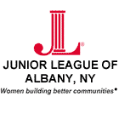

Strategic Plan 2011-2014

Goal 1: Sustain membership involvement, commitment to the mission and impact of the Junior League.
- Communication tools
  - Strengthen internal marketing and communications to better inform members of overall League efforts and accomplishments including other committee and council work so members can easily stay involved with League activities and more accurately articulate our mission, programs and projects with non-League people.
- Streamline e-mail messaging process.
- Enhance the calendar section of the website to include a more useful calendar of all JLA events and activities highlighting upcoming events and other critical member information.
- Develop a “Who to Contact” sheet for communicating within the League.
- Membership requirements
  - Develop a more efficient placement/ membership requirements tracking system.
  - Evaluate current membership requirements yearly and revise as necessary.
- Diversity Inclusion
  - Make a concerted effort to welcome members of all backgrounds.
- Meetings
  - Create more stimulating and informative general membership meetings.
- Increase the number of speakers at meetings from other community organizations.
- Offer councils and committees the opportunity to hold their meetings before or after the GMM’s.
- Provide “Done-In-A-Meeting” opportunities to enhance members’ sense of accomplishment at meetings.
- DIAD / Projects
  - Create Eighteen (18) volunteer opportunities, including DIAM’s, that benefit the community during the League year of September through May.
Goal 2: Establish Fiduciary Responsibility and Information Distribution
- Set in place internal controls over finances.
- Provide monthly financial reporting to the Board and membership on a regular basis complete with visuals.
- Furnish a brief summary of events/ fundraisers monthly at Board meetings and GMM’s.
- Research more fundraisers that appeal to both genders and out of League guests including our Community Partners.
- Have better yearly spacing of events to increase attendance.
- Important to ‘Tie- In’ event to league purpose- (“leaguers on the loose”)
- Evaluate the Dolly’s Imagination Library Project and investigate opportunities to transfer financial responsibility by the year 2013.
- Provide an explanation of what operational expenses dues cover at the January GMM.
- Regularly review current investments and reallocate as necessary.
  - Provide quarterly budget updates to Vice President’s to share with their committee chairs.
Goal 3: Improve Overall Brand Awareness and Community Impact

- Develop a 3-year plan that investigates new marketing opportunities to improve the visibility of the JLA.
- Participate in more community-scheduled events to generate brand awareness.
- Revisit Community Advisory Board (CAB) with clear job descriptions and goals by May 2013.
- Increase publicity and marketing opportunities by investigating the profitability of the following by December 2012:
  - Albany Colonie Chamber of Commerce Membership
  - JLA Business Cards

