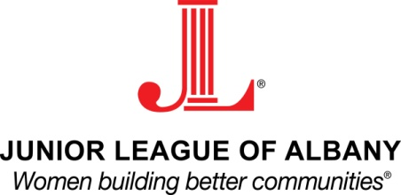
2014-2017 Strategic Plan

The Junior League of Albany Board of Directors has adopted the following Strategic Plan through May of 2017. This plan may be revised from year to year and an updated Strategic Plan shall be adopted following the completion of the 2016-2017 League year.

- Increase Brand Recognition
  - The JLA will quantify its success through a number of measures including but not limited to:
    - Increase Brand Recognition
      - Increase Membership
      - Implement an External Communication Plan
      - Increase sponsorship
        - 2 Mission-based Sponsors
        - 2 Event Sponsors
        - 1 Program Sponsor
    - Improve Membership Retention
      - Reduce Attrition of Members
        - 100 Active Members by JLA Centennial
      - Offer Fundraisers that members, their significant others and friends/family want to attend
    - Increase Community Impact
      - Develop a Long-Term Program
      - Develop a Short-Term Program(s)
      - Develop DIADs that are “on theme”
      - Identify Key Constituents
      - Assemble a Community Advisory Board
    - Improve Internal Processes
      - Amendment and Yearly Revision of Bylaws/Standing Rules
      - Increase Information Transfer and Provide Peer-to-Peer Training
      - Implement a Fund Development Plan
      - Implement an Internal Communication Plan

